**A PROPOSED OFFERING OF SALES COMMISSION SYSTEM FOR AU WATER REFILLING STATION**

A Thesis Project Presented to the

Faculty of Datamex College of Saint Adeline, Inc.

In Partial Fulfillment of the Requirements for the

Degree of Bachelor of Science in Information Technology

By:

Balansay, Rubylyn

Besa, Jaymark

Caranguian, Emilfred

Dayandante, Roniel

De Guzman, Joseph

Macayayong, Cedrix

Medina, Alfrancis

Tolentino, Jhay Vryllee

Tongco, Ciejay

May 2025

**APPROVAL SHEET**

This research paper entitled **“A Proposed Offering of Sales Commission System”** prepared and submitted by **Rubylyn M. Balansay, Jay-Mark F. Besa, Emilfred C. Caranguian, Roniel Dayandante, Joseph De C. Guzman, Cedrix John Macayayong, Alfrancis Medina, Jhay Vrylle L. Tolentino, Ciejay Tongco,** in partial fulfillment of the requirements for the subject Capstone Project and Research 2 in Bachelor of Science in Information Technology, has been examined and is hereby recommended for acceptance and approval for final oral defense.

Mr. Gabriel Thomas Torneros

Thesis Adviser

**PANEL MEMBERS**

Accepted and approved in partial fulfillment of the requirements for the subject Capstone Project 2.

Panel 2

Member

Panel 1

Member

Panel 3

Member

**ADVISER’S CERTIFICATE**

This is to certify that the thesis entitled **“A Proposed Offering of Sales Commission System”** prepared and submitted by **Rubylyn M. Balansay, Jay-Mark F. Besa, Emilfred C. Caranguian, Roniel Dayandante, Joseph De C. Guzman, Cedrix John Macayayong, Alfrancis Medina, Jhay Vrylle L. Tolentino, Ciejay Tongco,** in partial fulfillment of the requirements for the degree of Bachelor of Science in Information Technology, has been examined and is hereby recommended for approval and acceptance.

Prepared under my supervision.

Mr. Gabriel Thomas Torneros

Thesis Adviser

**ABSTRACT**

This study presents the development of a Sales Commission System for AU Water Refilling Station, a small-scale business in Dagat-Dagatan, Caloocan City, designed to enhance the efficiency of sales tracking, employee salary computation, and financial record-keeping. The project addresses the challenges of manual data processing, including time inefficiencies, human errors, data loss, and lack of security, which causing difficulties for the business’s operational performance.

The system was developed using VB.NET, .NET Framework 4.0, and SQL Server Management Studio 19, following a structured software development approach. Key features include secure user authentication with Gmail API integration for password recovery, computerized sales and salary computations, bills recording, report generation with Excel export, and an Archive for data recovery.

To evaluate the system’s effectiveness, a User Acceptance Test (UAT) was conducted with the business owner, Ms. Willjane Cipres. The UAT involved testing key scenarios such as login authentication, salary computation, report generation, and data restoration from an archive. Feedback collected over seven days indicated high user satisfaction, with the system praised for its ease of use, security, and efficiency in processing payroll and financial reports. One suggested improvement was the addition of flexible employee commission rates, which could enhance payroll customization.

The results demonstrate that the system successfully met its objectives, significantly reducing manual workload and improving data accuracy and security. The Sales Commission System is recommended for deployment in similar small-scale businesses to simplify the financial commission computation processes, support informed decision-making, and foster operational growth.

**ACKNOWLEDGMENTS**

First and foremost, I give all praise and glory to Almighty God, whose grace, wisdom, and strength have guided me throughout this journey. Without His divine guidance and blessings, this thesis would not have been possible.

We sincerely thank our project adviser, Mr. Gabriel Thomas Torneros, for his invaluable guidance, support, and encouragement throughout the development and deployment of the system. His expertise and constructive feedback played a crucial role in ensuring the success of this project.

Our heartfelt thanks also go to our client, Ms. Willjane Cipres, for trusting us with this project and providing us with clear requirements and timely feedback, which greatly contributed to the success of the system.

We would like to express our heartfelt gratitude for the successful implementation of our Sales and Commission System project for AU Water Refilling Station.

Furthermore, we would like to recognize the dedication and collaboration of all our team members. Each member’s time, skills, and commitment were instrumental in overcoming the challenges and completing the project efficiently and successfully.

This thesis is a reflection of all the people who have contributed to our growth, and we will remain forever thankful. We are grateful to everyone who contributed, directly or indirectly, to the completion of this project. Your support has been essential in achieving this milestone.

**TABLE OF CONTENTS**

**TITLE PAGEi**

**APPROVAL SHEETii**

**ADVISER’S CERTIFICATEiii**

**ABSTRACTiv**

**ACKNOWLEDGMENTv**

**TABLE OF CONTENTSvi**

**LIST OF FIGURESviii**

**LIST OF TABLESix**

**INTRODUCTION2**

**PROJECT OVERVIEW4**

Problem Statement5

Solution Overview5

Target Audience5

Deliverables5

**OBJECTIVES8**

Primary Objectives8

Secondary Objectives8

Success Criteria10

**SCOPE13**

Inclusions13

Exclusions14

Assumptions15

**TECHNOLOGIES USED17**

Programming Language17

Frameworks18

Tools18

**ARCHITECTURE20**

User Interface20

Business Logic Layer23

Data Access Layer24

**FEATURES29**

**USER GUIDE33**

Installation Instructions 33

Hardware Specification33

Software Requirement33

Installation Steps34

User Interface Overview35

**TECHNICAL DOCUMENTATION52**

Installation Guide52

Configuration54

API Documentation56

Code Documentation59

**TESTING74**

Objectives 74

Strategies74

Unit Testing75

Integration Testing75

System Testing75

Test Cases76

**DEPLOYMENT83**

Deployment Environment83

Deployment Steps84

**MAINTENANCE87**

Routine Maintenance87

Possible Maintenance88

Backup and Recovery Plan88

Upgrading Procedure89

Recovery Steps90

Troubleshooting Guidance91

**CONCLUSION95**

Achievements95

Lesson Learned96

Future Directions97

**APPENDICES100**

Appendix A - Gantt Chart100

Appendix B - Survey Questionnaire/Interview Questionnaire101

Appendix C- Curriculum Vitae103

**LIST OF FIGURES**

Figure 1: User Flow of Sales Commission System for Au Water Refilling Station 21

Figure 2: Business Logic Layer Diagram for Au Water Refilling Station 23

Figure 3: Database Schema Diagram for Au Water Refilling Station24

Figure 4. Sales Commission System Gantt Chart100

**LIST OF IMAGES**

Image 1: Login Interface35

Image 2: Forgot Password36

Image 3: Home Dashboard and Navigation Pane Interface37

Image 4: Editing Price Interface38

Image 5: Employee Information Interface 39

Image 6: Sold Interface 40

Image 7: Salary Interface42

Image 8: Gross Revenue Interface44

Image 9: Net Income Interface45

Image 10: Water Bills and Electricity 46

Image 11: Net Income Interface48

Image 12: Salary Interface49

Image 13: Archive50

Image 14: One of the Connection Class: Reports59

Image 15: Login Validation60

Image 16-1: Forgot Password and API61

Image 16-2: Forgot Password and API62

Image 16-3: Forgot Password and API62

Image 17: Sold Query 64

Image 18: Salary Query65

Image 19: Search Functionality 66

Image 20: One of the Generate Report: Income Report67

Image 21-1: Export Report68

Image 21-2: Export Report69

Image 21-3: Export Report69

Image 21-4: Export Report70

Image 22-1: Delete and Conserve to Backup Tables71

Image 22-2: Delete and Conserve to Backup Tables71

**CHAPTER 1  
INTRODUCTION**

**INTRODUCTION**

The world is changing, are humans aware of it? Yes, as the world is changing the rapid evolution of the digital landscape occurs and so, the need for innovative solutions to problems is greater now than it has ever been before. With the increasing demand for manpower in some kind of work, globalization addresses the problem by implementing a computerized process to fulfill the duty of a man or to lessen the workload, to be efficient, and to help human beings in their work.

The Au Water Refilling Station is a small range business company that runs in a Barangay of Dagat-dagatan in Caloocan City. This business running without any implementation of technology which shows they are still working with a manual process of data in their business. This project aims to address and provide a computerized system for their business, the purpose is to give them a technology that will help them to manage all of the data in their business efficiently. Recording in a manual process such as writing down the information in a notebook is prone to data loss and can’t be recovered easily same goes for reviewing information.

The development team desires to help and implement a computerized management system for their business, we aim to improve, and innovate the process they had; a manual to computerize our team wanted to develop a system that will help the business to process the data more easily than processing manually. Instead of writing down the data of the business and reviewing the information through paper pages, it can be done by just typing down and a click in a computerized system, we innovate to enhance a way of the data process in the Au Water Refilling Station by providing them a computerized system.

This document provides a guideline and information regarding the development of the project. As our stakeholder Au Water Refilling Stations owner Ms. Willjane Cipres signed an approval to become our client, we the development team will develop a Sales Commission System for her water refilling business.

We are a group of people who have our specialties, skills, and techniques to develop the right and useful system to address the challenges for the business, we also have different ways of testing phases to make sure the system functionalities and trustworthy analytics for planning and checking.

            Readers can expect to meet the project information, the purpose of the document, comprehensive guidelines for the software development project, the problem statement and resolutions, the objectives of the project, scope of the project and system’s features, functionalities, and limitations, components such as hardware and software components, frameworks and diagrams like flowchart to provide a better visual representation for reader’s understanding, guidelines, testing, deployment and maintenance plans. These are the brief outline structure of the document to aid readers with this document's contents.

**CHAPTER 2**

**PROJECT OVERVIEW**

**PROJECT OVERVIEW**

This section provides a general background and brief description of the proposed system. It outlines the key purpose of the project and what readers can expect to learn, including the challenges being addressed, the solution being offered, the intended users, and the expected outcomes of the project.

**Problem Statement**

Processing the income and expenses in manual way of the Au Water Refilling Station. Using the manual way, it consumes a lot time to record and monitor the sales and employee of the business that leads to inefficiencies and time wastage. It is also prone to human error that will affect the accuracy and consistency of the records. The manual records may lack of proper security and high risk of data lost. Moreover, handwritten records are susceptible to alterations or tampering, compromising data integrity.

**Solution Overview**

Having a Sales Commission System as a solution to the issues or problems that's addressed for Au Water Refilling Station. It can computerize the recording and monitoring of sales and salary that allows to reduce time required for this task. It's also reduced the human error by using this system. Using the Sales Commission System, they can perform calculations of the income and expenses accurately. It's also had better security compared to manual records by having the backups in the system and also prevent from unauthorized access to avoid loss of data.

**Target Audience**

Business owner specially the Au Water Refilling Station who can benefit our project. Using our system, it saves the business a lot of time and efforts instead of doing the task in a manual process. It's promoting the accuracy and efficiency of a business to prevent loss of income and data.

**Deliverables**

Upon successful completion of the project, the development team will provide the following deliverables to ensure full functionality, usability, and maintainability of the system.

1. A fully developed Sales Commission System.
2. Necessary supporting documents such as,

* Project Proposal
* Design Documentation
* Software Requirement Specification
* Technical Documentation
* Testing Documentation
* Deployment Documentation
* Maintenance Documentation

1. User manual for system navigation and usage.
2. Flash drive containing the complete system and documentation.
3. Online GitHub repository for source code versioning and access.

**CHAPTER 3**

**OBJECTIVES**

**OBJECTIVES**

This chapter outlines the goals and expected outcomes of the Sales Commission System.

**Primary Objectives**

The primary objective of this project is to develop a comprehensive and efficient system that simplify processes, enhances productivity, and ensures seamless functionality. By integrating modern technologies and industry best practices, the system will address existing inefficiencies, computerize tasks, and improve data monitoring. Designed for scalability, security, and user accessibility, it will provide a smooth and intuitive experience while laying a strong foundation for future enhancements and operational growth.

* Understanding the workflow of currently manual processing in the business.
* Analyze the struggles and needs of the client for the innovation of the process.
* Making sure the computerized system can adopt to implement in stakeholder’s environment.
* List down the key features needed for the client to accomplish the same process of her management in the business.
* Development of the Sales Commission System according to the stakeholder’s need.

**Secondary Objectives**

These secondary objectives serve as a guideline for the development team, ensuring a structured and efficient approach to the project's development while maintaining alignment with its overall goals and requirements.

* Documentation, creating a documentation for the development team, client and future readers to guide in planning, development and implementation of the project.
* Provide a concrete plan for taking the additional steps to accomplish the system development and implementation.
* Creating a diagram, such as user flow, data process, use case and system architecture.
* Creation of database schema, and understanding the system’s features processes to achieve the computerized processes of management in the business.
* Make a concrete plan for unintentional loss of the system and document due to unexpected circumstances such as, calamity and data corruption.
* Listing an initial plan for testing phase, included the steps in alpha testing, beta testing and conducting a roleplay scenario as user and a prototype computerized system.
* Creation of implementation procedure, and guideline for the user such as user manual and maintenance.

**Success Criteria**

This checklist serves as a benchmark for the development team and stakeholder to determine whether the project has been successfully accomplished, ensuring that all goals, requirements, and quality standards have been met.

1. **Business Process Understanding**

If the development team successfully documented and validated analysis of the current manual workflow in the business and has confirmation from the stakeholder that all key manual processes are understood and considered in the system development.

1. **Stakeholder needs Fulfillment**

If all key features requested by the client are implemented and tested and the system meets at least 90% of the stakeholder's operational requirements for Sales Commission System.

1. **System Environment Readiness**

If the implementation has successful in installation and configuration in the business environment and no major compatibility issues encountered during system deployment.

1. **System Development Milestones Completion**

If the secondary objectives meet the requirement and accurate by providing detailed system architecture diagrams, user flows, and database schemas completed and approved by the stakeholder and supervisor. If the plan in testing was completed including the functional prototype demonstration during beta testing.

1. **Data Security and Backup Measures**

Backup and recovery strategies documented and tested to protect against data loss (e.g., data corruption or calamity).

1. **Testing and Quality Assurance**

Successful completion of alpha testing with documented issue resolution and improvements and in beta testing with at least 85% positive user feedback and zero critical issues remaining.

1. **Comprehensive Documentation**

Has completed user manuals and maintenance guides for system operation and well-organized development documentation for future maintenance and upgrades.

1. **Training and User Familiarity**

Training sessions conducted for user, with at least 90% shows that the user can use the system effectively.

1. **System Performance and Efficiency**

System handles projected business operations load without major performance issues and has average response time within acceptable limits for key operations.

1. **Deployment and Implementation Success**

Providing a smooth transition from manual to computerized system with minimal business disruption positive feedback from user confirming enhanced operational efficiency.

**CHAPTER 4**

**SCOPE**

**SCOPE**

The scope of this project defines the boundaries and limitations of the Sales Commission System for AU Water Refilling Station. It outlines what the system will do, who will use it, and where it will be implemented. The system will focus on managing sales transactions, employee records, salary computation, and generating reports.

**Project Scope**

The system is intended for use by the business owner Ms. Willjane Cipres of AU Water Refilling Station, located in Dagat-Dagatan, Caloocan City. It will be deployed on a local computer in the owner’s household almost 1-2km within the business premises. This project will not include features such as inventory tracking, delivery management, and online payment integration.

**Inclusion**

The system includes essential features for efficient business management, such as user information for secure login and credential recovery, sales manipulation for pricing, commissions, and income tracking, and salary computation based on deliveries. It also offers bills recording for tracking monthly expenses, reports display for generating sales and employee reports, and data backup and retrieval to restore deleted records when needed. These features ensure a simple, computerized, and user-friendly experience.

1. **User Information**

It includes the login authentication and used an API for integrating the Gmail for credentials recovery once the user forgot the login credential.

1. **Sales Monitoring**

This feature includes manipulation of prices, employee commission percentage, adding gallon sizes, daily computation of the net income and this feature has relationship to the employee information to be able to compute the salary of the employee by their rate per gallon.

1. **Employee Management**

This feature included the addition of employee information, computation of their salary based on the gallons they delivered per day.

1. **Bills Recording**

Bills recording is a feature that only records the amount of the monthly expenses by the user in their business, this is an individual feature that shows to the user for their record only.

1. **Reports Display**

This report feature came from the generated report of sales and employee information based on the selected rows, by month and year.

1. **Data Backup and Retrieval**

Whenever the deletion of data from the sales and employee it goes to recycle bin, it acts like an archive which stores the data after deletion so it can be restored if the data still needed.

**Exclusion**

The former is used in the above-mentioned exceptions to ensure that the attention is shifted to the aspects of a system and to define responsibilities. Its purpose is to prevent or minimize such misconceptions and also to decelerate or speed up each other’s tasks. Besides, it helps each member of the group to understand their roles, which lead to achievements in the two organizations.

1. **Hardware Maintenance.** The maintenance, hardware repair, and replacement are not part of our project. This activity is the client's or third-party service provider responsibility.

**Assumption**

The development team has outlined several assumptions regarding the expected outcomes and effectiveness of the system. These assumptions are based on the system's features, functionality, and the anticipated user experience. The system is designed to enhance efficiency, accuracy, and convenience by computerizing key processes such as sales monitoring, employee salary computation, and data recording. It is assumed that user will find the system intuitive and that its features will significantly reduce the manual workload, minimize errors, and improve data monitoring.

1. The sales manipulation works efficient than the manual processing because of its computerized calculation and record with relationship of employee salary.
2. Record data by typing the appropriate value improves correctness.
3. Provides easy recording display for the user when the data was generated.
4. The system can hold the deleted information and retrieve them whenever the user needs them back.
5. The login authentication and Gmail integration for credential recovery will enhance security and user accessibility, reducing issues related to forgotten credentials.
6. The system's structured sale manipulation feature will enable accurate tracking of daily net income, ensuring transparency in financial transactions.
7. Employee salary computation based on delivered gallons will provide a fair and computerized payroll system, minimizing miscalculations.
8. Bills recording will serve as a reliable reference for monitoring monthly business expenses, assisting user in financial planning and budgeting.
9. The reports display feature will allow user to efficiently analyze business performance by filtering data based on specific timeframes, improving decision-making.
10. The recycle bin function will act as a safeguard against accidental data loss, ensuring that deleted sales and employee records can be restored when necessary.

**CHAPTER 5**

**TECHNOLOGIES USED**

**TECHNOLOGIES USED**

These are the technologies and components used in the development of the project, including the programming languages, frameworks, and tools essential for building a robust and efficient system. The system utilizes a combination of server-side and client-side technologies to ensure seamless functionality, security, and scalability. The chosen technologies support data management, user authentication, and computerize processing, contributing to the overall performance and usability of the Sales Commission System

**Programming Language**

In the development of the system, the development team utilized VB.NET as the primary programming language to address the specific needs and challenges faced by our client. This language was chosen because it offers robust features that enable the creation of solutions aimed at streamlining and enhancing the efficiency of business processes. By leveraging this technology, we were able to deliver a system tailored to the client's requirements, contributing to a faster, more organized, and effective workflow.

The use of Visual Basic not only allowed us to develop a highly functional system but also highlighted how technology can improve the client’s operational skills and foster better familiarity with computerized processes.

**Data Storage and Management**

For data storage and management, the development team integrated the system with SQL Server Management Studio 19. This versatile database management tool ensures secure and efficient storage of all data input by the client. With SQL Server Management Studio 19, records can be quickly accessed, searched, and retrieved, significantly reducing the time and effort needed for data management. This solution addresses the common issue of data loss associated with manual processes. SQL Server Management Studio 19 also provides built-in backup functionalities, offering a reliable safeguard against potential data corruption or accidental loss.

**Frameworks**

The .NET Framework, developed by Microsoft, is a comprehensive software development platform that selected by the development team for the project Sales Commission System. This framework offers powerful tools and extensive libraries that enable the creation of efficient and reliable software solutions. The .NET Framework Class Library provides a wide range of resources for data handling, user interface development, and system processes, allowing seamless integration between different components of the system.

**Tools**

1. **Visual Studio 2010**

This served as the primary development tool for coding, designing, implementing system functionalities, and debugging. The development team relied on Visual Studio 2010 to build the core features of the AU Water Refilling Station Sales Commission System.

1. **SQL Server Management Studio 19**

The development team utilized SQL Server Management Studio 19 (SSMS 19) as the database management tool for the system. Its powerful features enabled efficient data management, storage, and retrieval, ensuring scalability and reliability. With SSMS 19, the team could execute queries, manage database structures, and optimize performance, making it a suitable choice for handling the system’s data requirements.

**CHAPTER 6**

**ARCHITECTURE**

**ARCHITECTURE**

The Sales Commission System for AU Water Refilling Station is designed to meet all of the necessary functionalities, and components to provide efficiency in fulfilling its task for the business. The system consists of three (3) layers of components each of which has its purpose in working together to make the system’s functionality successful. The components are the User Interface (UI) front-end layer of the system, where user interact with the application. Business Logic Layer (BLL) as the core of the system, processing inputs from the UI and executing the business rules and operations essential for the Au Water Refilling Station. Data Access Layer (DAL) serves as the intermediary between the BLL and the Database.

**User Interface (UI)**

The User Interface is the front-end component and it interacts with user. It includes software windows such as login, dashboard, and task management a component layer that is visible for user for them to interact.

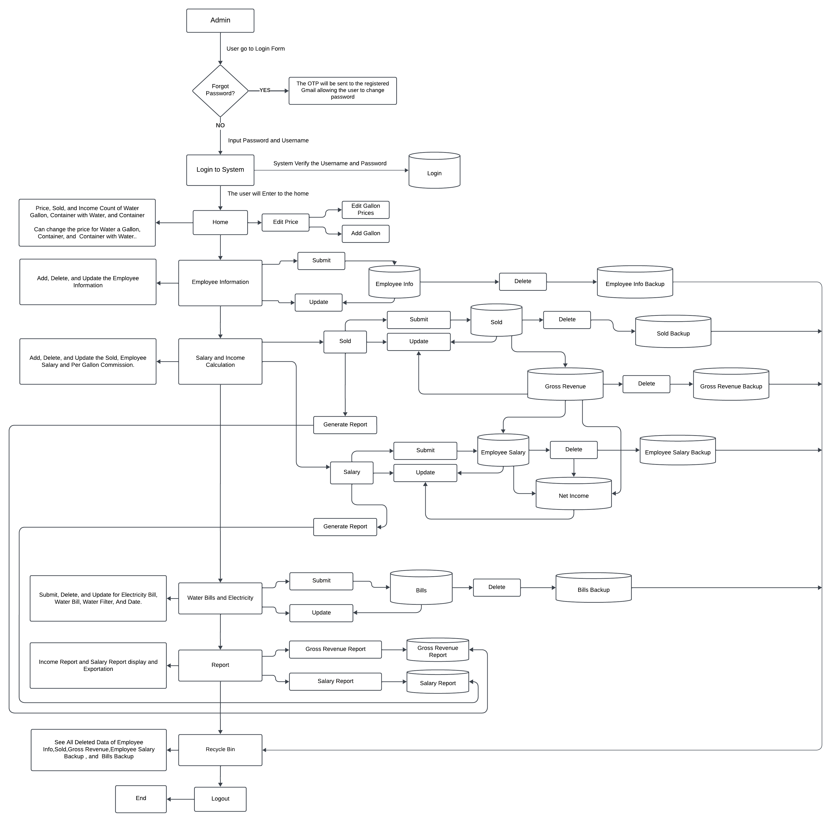

**Figure 1. User Flow of Sales Commission System for Au Water Refilling Station**

This figure aims to help the user analyze the journey and optimize the user experience. It provides for clear visualization of understanding of how the software will process if the user manages to use it.

**Functionalities**

1. **User Authentication**. Secure login system for the client with credential recovery via Gmail integration.
2. **Sales Commission Manipulation**. Adjusting product prices, tracking sales, computing daily net income, and managing employee commission percentages.
3. **Data Manipulation**. Performing input, edit, update, and delete operations on records.
4. **Computerized Salary and Sales Computation.** Calculating employee salaries and net income based on sales data and commission rates.
5. **Bills Recording**. Logging monthly expenses for financial tracking and business analysis.
6. **Report Generation**. Creating sales and employee reports based on selected filters such as month and year.
7. **Archive**. Deleted records are stored in a recycle bin, acting as an archive for future restoration.
8. **Search Functionality**. Allows user to quickly locate records within sales and employee data.
9. **Excel Export**. Supports exporting reports in Excel format for external use.
10. **User-Friendly Interface**. Ensures ease of use with an organized dashboard and accessible functionalities.
11. **Scalability and Security**. Utilizes SQL Server Management Studio 19 (SSMS 19) for reliable data management and secure transactions.

**Business Logic Layer (BLL)**

The Business Logic Layer is the one that handles the logic of the business, such as its rules and it also processes the input of the user from the UI to perform necessary operations. This is the process of how the data flows within the operation of the Sales Commission System for the Au Water Refilling Station.

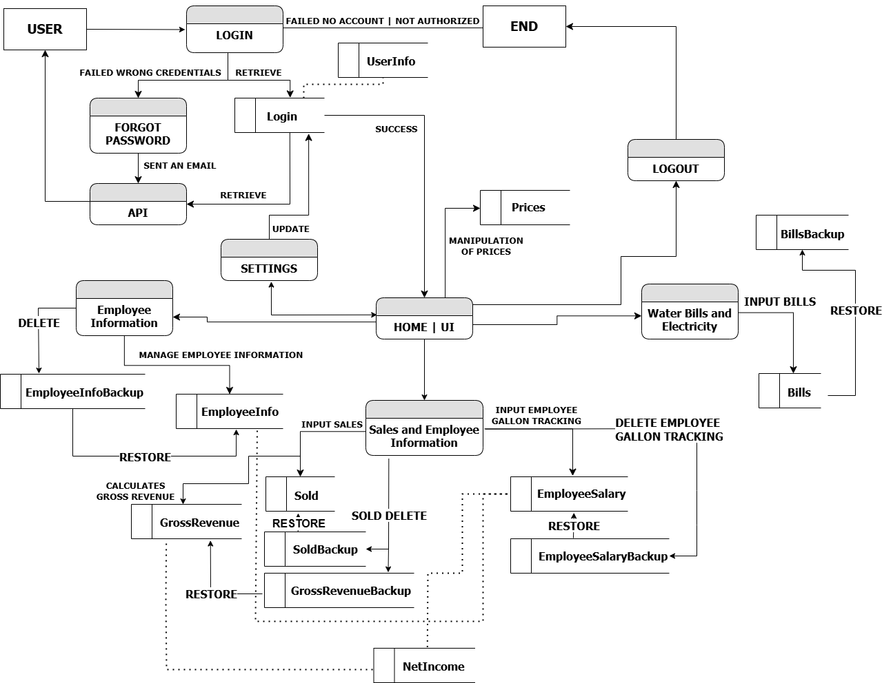

**Figure 2. Business Logic Layer Diagram for Au Water Refilling Station**

The Business Logic Layer (BLL) Diagram represents how the system processes and manages data between the User Interface (UI) and the Database Layer. It defines the core functionalities that handle business rules, ensuring accurate computations and data management.

**Data Access Layer (DAL)**

The Data Access Layer is the one that manages all of the interactions within the database, it ensures the data is stored and can be retrieved efficiently by a set of appropriate command logic in the development of the script.

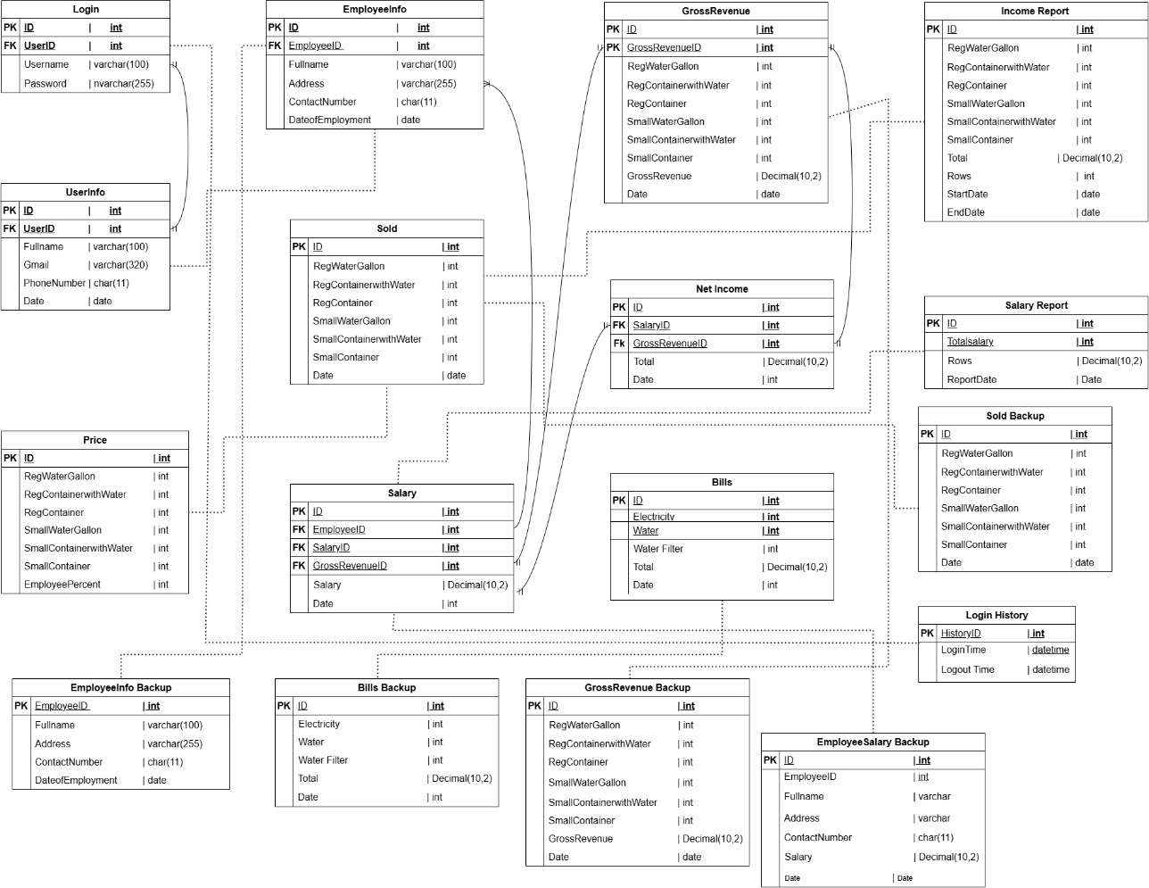

**Figure 3. Database Schema Diagram for Au Water Refilling Station**

This figure shows the relationship of some tables in order to achieve the efficient work flow of processes in the system.

**Tables Information**

The database is structured to efficiently monitor sales, employee records, and financial transactions while ensuring smooth data retrieval and integration across different system modules. Below is an overview of the key tables, their fields, and their relationships within the AU Water Refilling Station’s Sales Commission System.

* **Login**

The Login table stores user credentials used for authentication. It contains fields such as username and password, which are validated during login attempts to verify user access.

* **LoginHistory**

The login history logs every successful login of the user account which is the admin account for the Sales Commission System for AU Water Refilling Station owned by Ms. Willjane Cipres

* **UserInfo**

The UserInfo table contains essential details about the system user. It includes basic information such as the full name, contact number, and email address. This table has a relationship with the login table to retrieve the associated username and display it alongside the user's other details in the system settings.

* **Price**

The Price table stores gallon pricing set by the user. The values in this table are used to computerize sales calculations, ensuring accurate pricing for different product sizes.

* **EmployeeInfo**

The EmployeeInfo table stores details about employees, particularly delivery personnel. It includes fields such as EmployeeID, full name, and contact number.

* **Sold**

The Sold table records daily sales transactions, storing information on the quantity and type of products sold. This includes different gallon sizes, gallons with water, and empty containers.

* **Salary**

The Salary table tracks employees' daily earnings. It is directly linked to the EmployeeInfo table via EmployeeID to ensure accurate payroll computation. The system calculates salaries based on the number of gallons delivered with specified amount for commission, and this table stores the computed amounts for each employee. This table plays a crucial role in payroll processing, as it provides data needed to calculate daily wages based on the number of gallons delivered.

* **GrossRevenue**

The GrossRevenue table holds the total value of daily sales. It stores the computed total for each product type, allowing the user to track business revenue efficiently.

* **NetIncome**

The NetIncome table calculates and stores the business's net income for the day. It derives its values from the GrossRevenue, Salary and Expenses tables, ensuring that the computed net income accurately reflects total earnings after deduction of employee salary and expenses.

* **Bills**

The Bills table records monthly business expenses. It serves as a financial tracking tool, helping the user monitor and manage operating costs.

* **IncomeReport**

The IncomeReport table generates income summaries based on user-selected date ranges from the Sold table. It provides detailed insights into revenue trends and performance.

* **SalaryReport**

The SalaryReport table generates salary records based on date selections from the Salary table. It allows the user to track employee payroll history efficiently.

* **Backup Tables**

All backup tables serve as archive storage for deleted data. Whenever a record is removed from key tables such as Sales, EmployeeInfo, or Salary, it is stored in a corresponding backup table. This feature ensures that data can be retrieved and restored if necessary.

**CHAPTER 7**

**FEATURES**

**FEATURES**

This section outlines the key functionalities of the Sales Commission System for AU Water Refilling Station. It serves as a guide for stakeholder, developers, and user to ensure that the system meets business needs. Additionally, it provides clear documentation of the system’s capabilities.

**Features of the Sales Commission System**

The Sales Commission System includes various features designed to simplify business operations. These features help manage employees, track sales, record expenses, and computerized payroll processes, ensuring efficiency and accuracy in daily transactions.

* **Feature 1: User Login and Authentication**

The system includes a secure login feature that allows the client to access the platform. It verifies login credentials and ensures that only the authorized user can enter the system. This feature helps protect sensitive business data and prevents unauthorized access.

* **Feature 2: Forgot Password Recovery**

The system provides a password recovery feature integrated with Gmail API, allowing the user to reset their password if forgotten. This ensures secure account recovery while maintaining system security.

* **Feature 3: Account Settings and Password Personalization**

The system allows the user to update personal information and change their password. This ensures account security by enabling regular updates, reducing the risk of unauthorized access.

* **Feature 4: Home Dashboard**

The Home Dashboard provides an overview of daily sales, total income, and employee salaries. It allows the user to manage product prices, monitor financial and performance.

* **Feature 5: Employee Information**

This feature enables the storage and updating of employee records, including basic personal details. It ensures that employee information is well-organized and accessible when needed.

* **Feature 6: Salary and Income**

This feature allows the user to input and manage daily sales transactions. The system computerize computes the gross revenue based on sales data and tracks all financial records efficiently.

* **Feature 7: Salary Computation**

Employee salaries are computed based on their daily deliveries. The system calculates earnings based on the number of gallons delivered with specified amount for commission, ensuring accurate salary computation and reducing manual payroll errors.

* **Feature 8: Bills Recording**

The system records monthly business expenses, such as water and electricity bills. This allows the user to track expenses separately from income and plan financial budgets accordingly.

* **Feature 9: Reports Generation and Exportation**

The system enables the user to generate reports on sales, employee salaries, and overall business performance. These reports can be exported in Excel format, allowing for easy analysis and record-keeping.

* **Feature 10: Search Functionality**

The system includes a search feature, allowing the user to quickly find specific sales records, employee details, or reports for faster data retrieval.

* **Feature 11: Archive**

Deleted records are temporarily stored in a Recycle Bin, allowing the user to restore important data when necessary. This prevents accidental data loss and ensures business records remain recoverable.

The Sales Commission System is designed to enhance efficiency, display financial tracking efficiently, and improve record-keeping for AU Water Refilling Station. It simplifies sales monitoring, payroll computation, and business reporting, making daily operations more manageable and accurate.

**CHAPTER 8**

**USER GUIDE**

**USER GUIDE**

This chapter includes clear instructions, screenshots, and step-by-step guidance to help user understand and navigate the system.

**Installation Instructions**

The installation instructions guide users through the process of setting up the AU Sales Commission System on the personal computer. It includes system requirements and step-by-step installation procedures. These instructions ensure a smooth free and error-free installation, enabling the user to run the system efficiently.

**Hardware Specifications**

The hardware specifications define the necessary computing resources required to efficiently test the system. This ensures that performance is accurately measured and system compatibility is verified across different configurations.

* **Processor**. Intel Core i3 or higher
* **RAM**.  4GB or higher
* **Storage**. 256GB SSD or higher
* **Operating System**. Windows 10/11
* **Network**. The system can function even without internet connection

**Software Requirements**

The software requirements outline the essentials tools and platforms used during testing. These tools help in automating tests, managing databases, and ensuring the system runs as expected in different environments

* **Operating System.** Windows 10/11 (32-bit or 64-bit)
* **Database Management System.** SQL Server Management Studio Management Studio 19
* **Framework.** .NET Framework 4.0

**Installation Steps**

**Step 1.** Install the SQL Server Management Studio in any search engine browsers.

**Step 2**. Import the database of the system.

**Step 3.** Download the installer from a flash drive or cloud storage like Google Drive. Extract the compressed file if applicable

**Step 4**. After copying the installer, open the folder.

**Step 5**.Double click the setup.

**Step 6**. If a message show asking if you are sure run this program, click “Yes”.

**Step 7.** Wait until it is successfully installed and the login page will show means the installation is successful.

**Step 8**. The user can search the software on the search bar beside the windows logo.

**Step 9**. Click it and you can now access the software anytime.

**Step 10.** You can create a shortcut of the software by searching the name of software, right click on it and click send to and choose desktop. You can now see the icon of the software on your desktop.

**User Interface Overview**

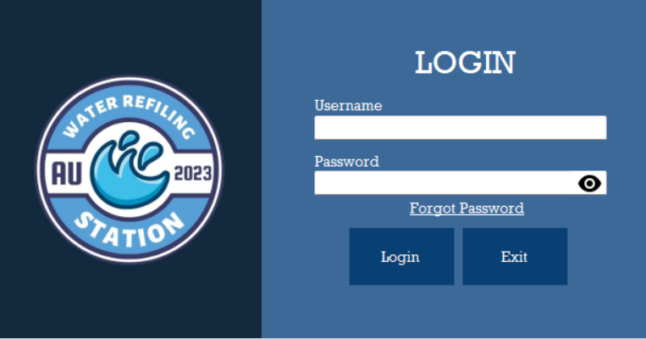 This section describes the layout and navigations of the user interface of the Sales Commission System for AU water refilling station.

**Image 1. Login Interface**

1. **Log In Interface**

* **Username and Password**. These fields are used to verify if the user is the user that allowed to access the system.
* **Eye Icon**. This icon is use show the password.
* **Forgot Password**. One of key features of the system that is use to retrieve the password to have access again on the system if the user accidentally forgot her password
* **Login**. A button use in proceeding and verifying the username and password.
* **Exit**. A button use to exit on the system.

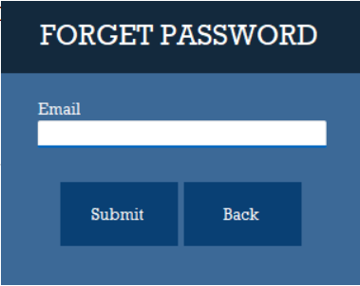

**Image 2. Forgot Password Interface**

1. **Forgot Password Interface**

* **Email**. For the user to be able to retrieve his password, the user must enter her registered email.
* **Submit**. A button use to submit the inputted email and send the recovery instruction to the email.
* **Back**. A button use to back from the login interface

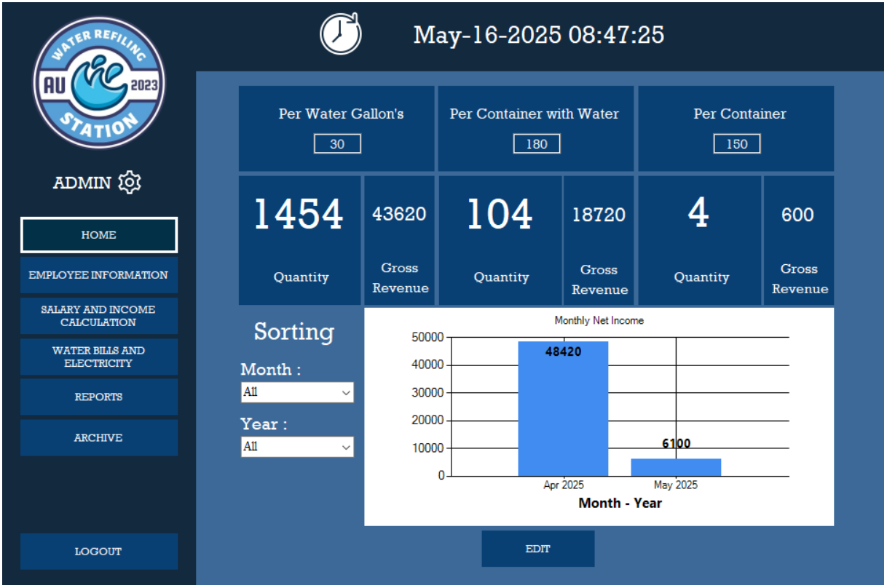

**Image 3. Home Dashboard and Navigation Pane Interface**

1. **Home Dashboard and Navigation Pane Interface.**

* **Navigation Pane.** On the navigation pane interface, the user can see buttons which function are the key features of the system
* **Dashboard.** The dashboard shows the prices of different variations of gallons and gallon with water available at AU water refilling station.
* **Edit.** Button use to edit the price the different variations of gallon and gallon with water.
* **Sorting.** Use to sort the tracking of monthly income of the business.

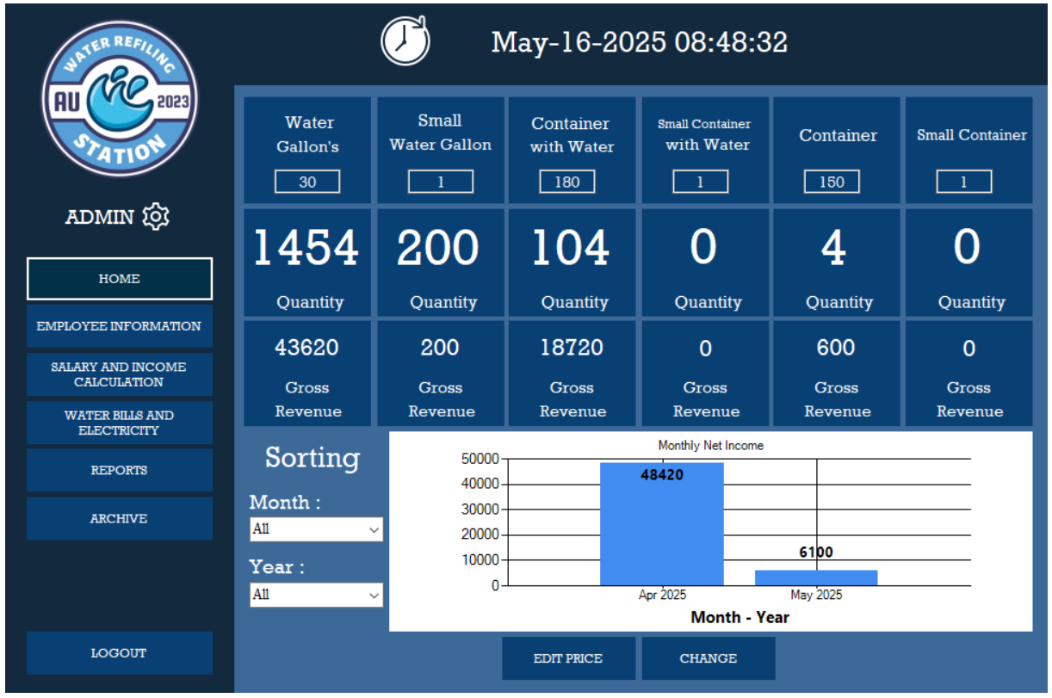

**Image 4. Editing Price Interface**

1. **Editing Price Interface**

* **Edit Price.** The first button need to click to edit the price. After clicking it the price field are enable to modify the prices.
* **Change.** After modifying the prices, just click the “Change” button to save the edited prices

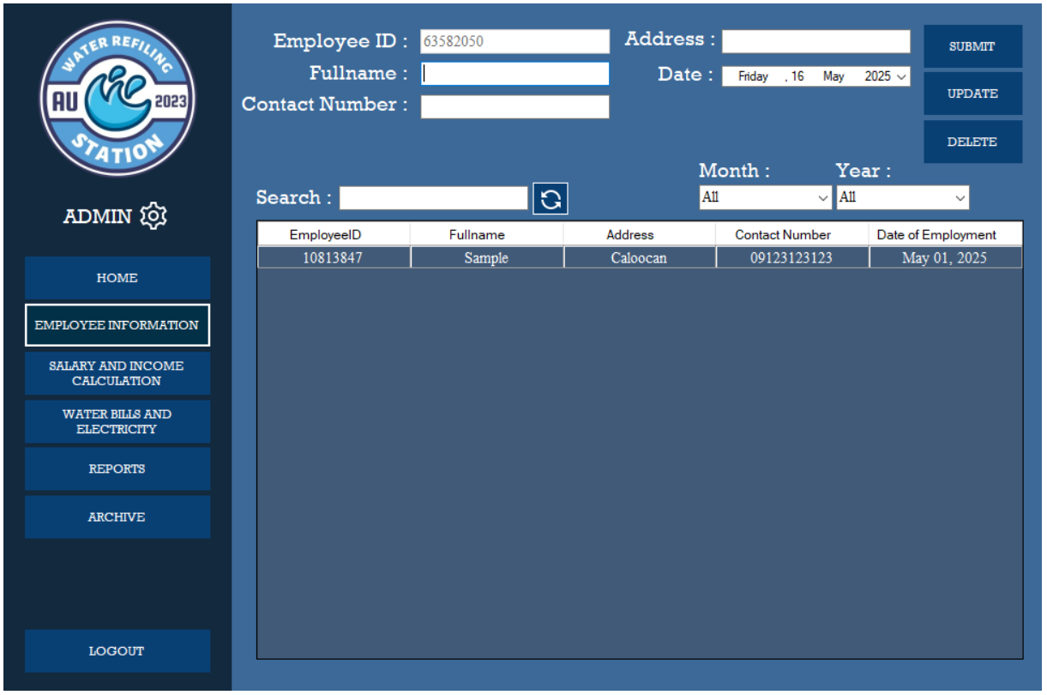

**Image 5. Employee Information Interface**

1. **Employee Information Interface**

* **Employee ID.** A auto-generated field for unique identification for each employee.
* **Fullname.** A field where the user can input the fullname of the employee
* **Contact number.** Employee contact number
* **Address.** Employee’s address
* **Date.** Date of employment
* **Submit.** Use to submit or save the employee information
* **Update.** Use to update employee information
* **Delete.** Use to delete employee information
* **Search.** Use to search on record of employees.
* **Refresh Icon.** Use to refresh the page.
* **Month and Year.** Use to sort the record by month, by year, or by month and year

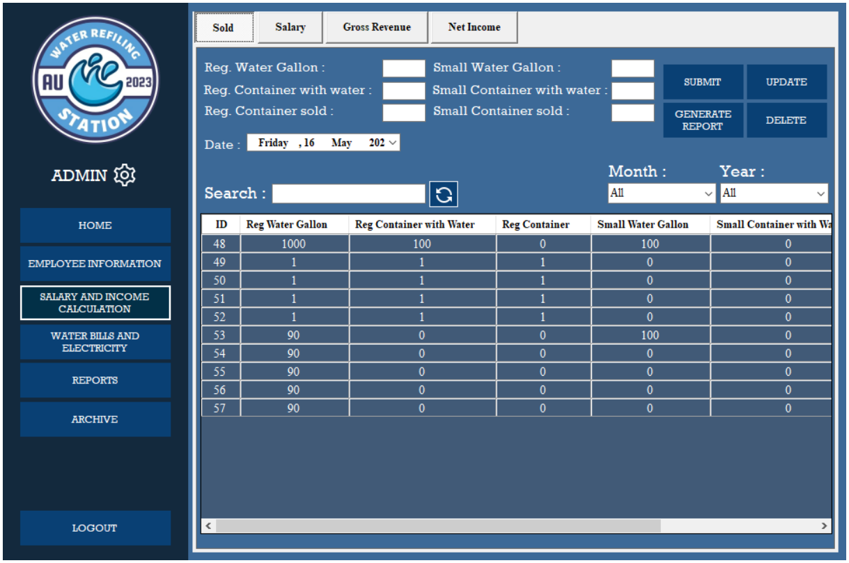

**Image 6. Sold Interface**

1. **Sold Interface**

* **Reg. Water Gallon.** A field use for entering the quantity of sold regular water gallon.
* **Reg.** **Container with water.**  A field use for entering the quantity of sold regular container with water
* **Reg.** **Container sold.** A field use for entering the quantity of sold regular container.
* **Date.** Use for choosing the date where the quantity of products are sold.
* **Submit.** A button for submitting the sold record for that day.
* **Update.** A button use to edit and save the record of sold.
* **Delete.** A button user to delete row of record.
* **Generate Report.** This button is use after selecting the row of the record that the user want to generate a report.
* **Search.** Use to search a record within the table below.
* **Month and Year.** Use to sort record by month, by year,or by month and year.
* **Refresh Icon.** An icon beside the search field that is use just to reload or refresh the page.
* **Record Table.** A field where the saved records are shown.

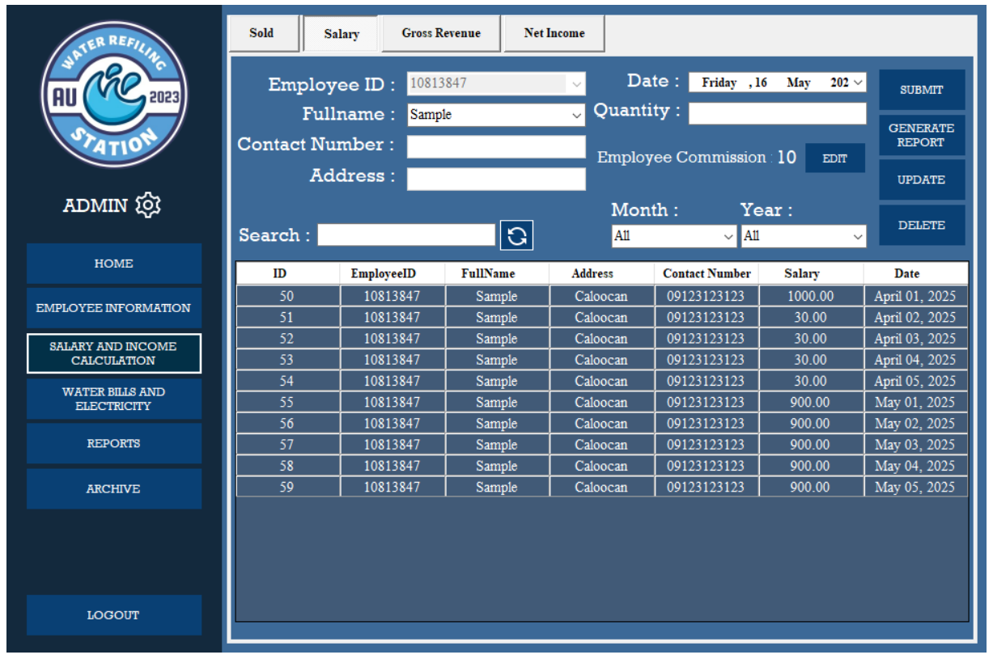

**Image 7. Salary Interface**

1. **Salary Interface**

* **Employee ID**. This field on the salary menu is disable which mean the user is unable to input or type any characters. The use of this field is to show the unique ID of and employee.
* **Fullname**. This field is a drop down list where the user only choose the name of employee.
* **Contact Number**. This field is also disable. The field will have its information after choosing the fullname and it will display the contact number of chosen employee.
* **Address**. This field is also disable. The field will have its information after choosing the fullname and it will display the Address of chosen employee.
* **Quantity.** This field is use to input the quantity of water gallon sold on that day. This is the base of the calculation of salary of an employee.
* **Search.** A field use to search a record on table below.
* **Month and Year.** Use to sort the record by month, by year, or by month and year

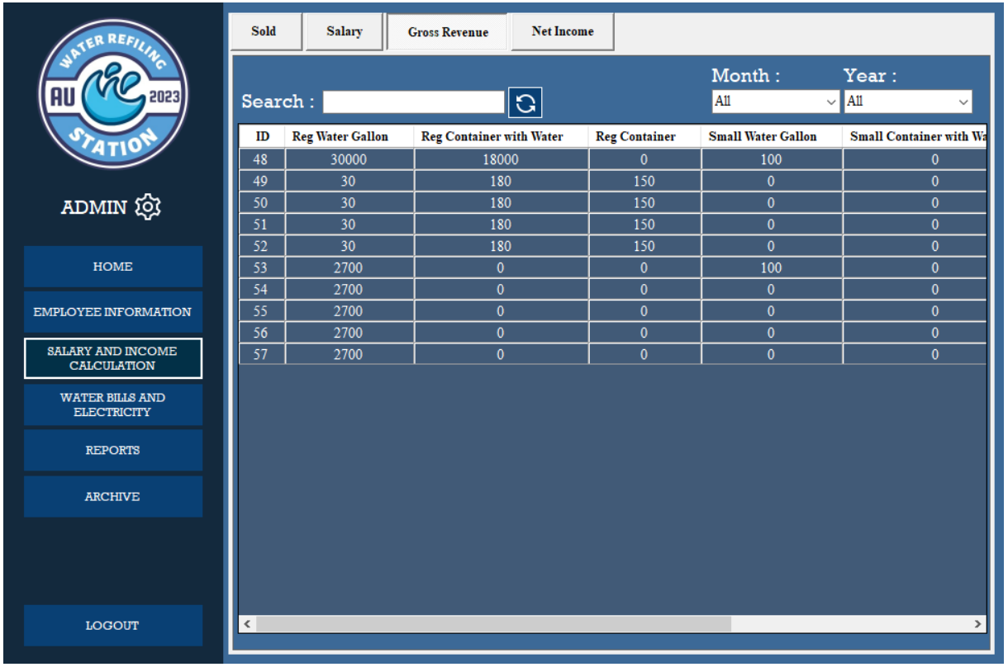

**Image 8. Gross Revenue Interface**

1. **Gross Revenue Interface**

* **ID**. This is the field where the number of data inputs is counted.
* **Reg. Water Gallon.** Here you can see how many water gallons were sold and how much profit was made from the water gallons sold.
* **Reg. Container with Water.** This will show how many gallons container were sold and how much profit was made from the water containers sold.
* **Reg. Container.** This is where you ca record containers were sold and how much profit was made from the regular containers sold.
* **Gross Revenue.** Here you will see the total profit of gallons sold.
* **Date.** Here you will find out how much you earned gross income that month.

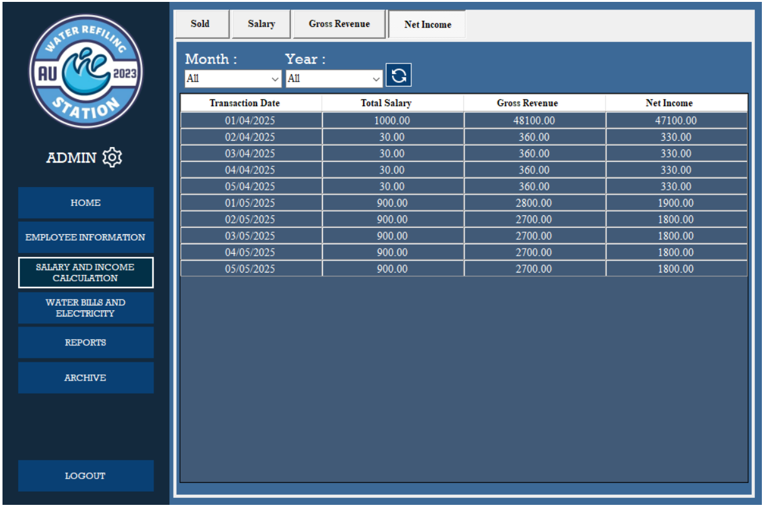

**Image 9. Net Income Interface**

1. **Net Income Interface**

* **Transaction Date.** Here you can see which month the transaction occurred.
* **Total Salary.** Here you can see the total amount spent on bills, salaries etc.
* **Gross Revenue.** Here you can see the total income for this month.
* **Net income.** Here you will find out how much money is left after all expenses are deducted.

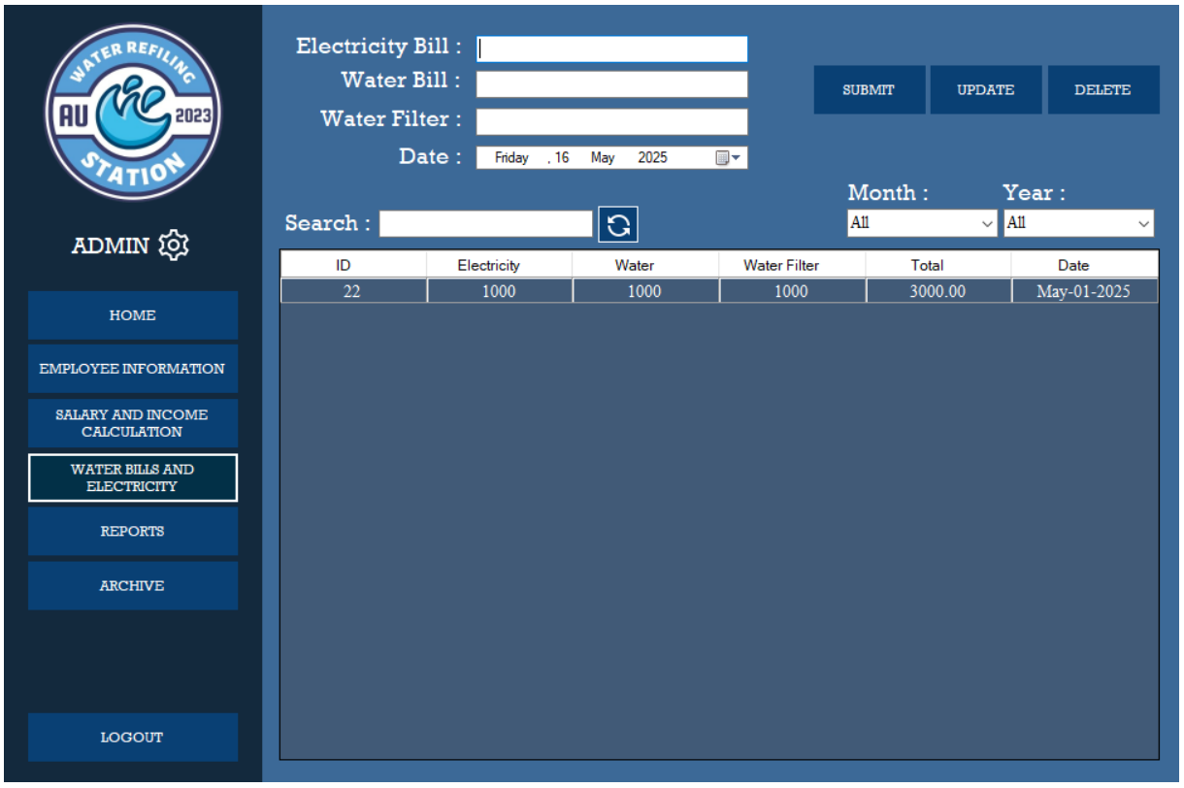

**Image 10. Water Bills and Electricity**

1. **Water Bills and Electricity**

* **Electricity Bill.** A field where you can enter the amount of the electricity bill,
* **Water Bill.** A field where you can enter the amount of the water bill.
* **Water Filter.** A field where you can enter how many water filters are needed or how many have been used.
* **Date.** Date when the bills arrived.
* **Search Bar.** A field use to search a record on table below.
* **Submit.** Use to submit the amount of bills.
* **Update.** Use to update the amount of bills.
* **Delete.** Use to delete the amount of bills.
* **Refresh Icon.** Use to refresh the page.
* **Month and Year.** Use to sort the record by month, by year, or by month and year.

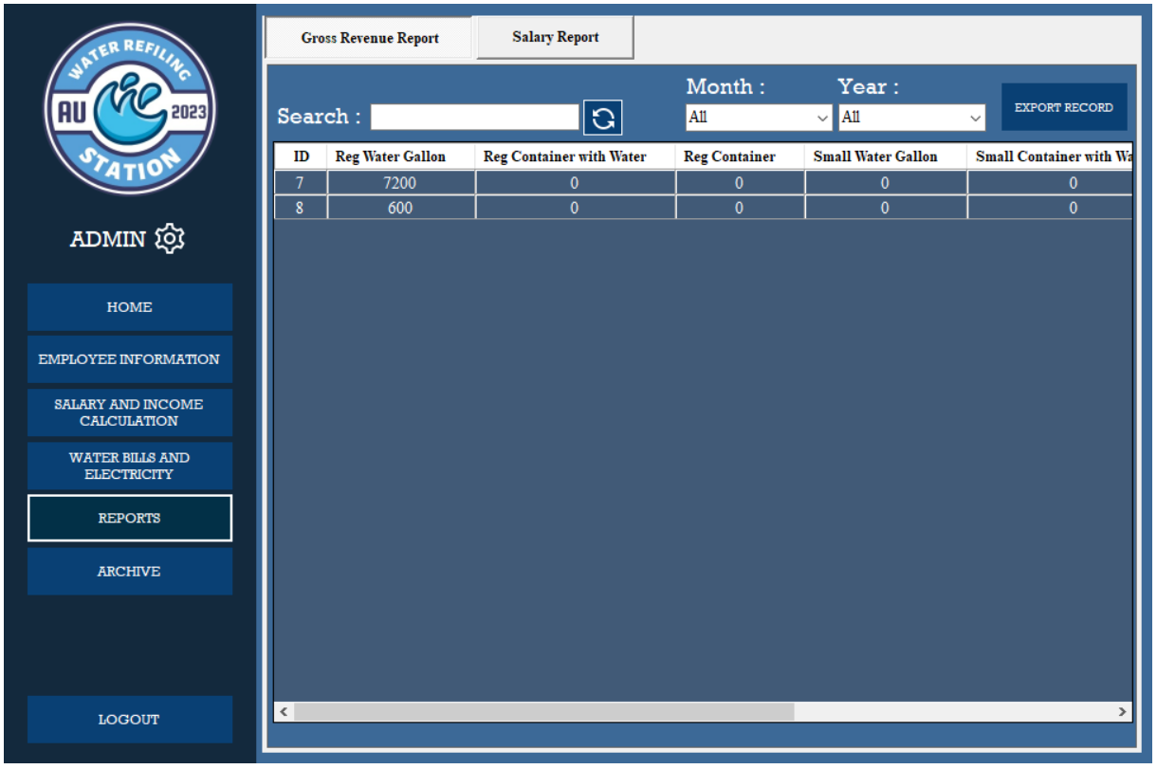

**Image 11. Reports Interface**

1. **Reports Interface**

* **Gross Revenue Report.** This field show the total revenue of the shop.
* **Export Record.** A button use to export a soft copy of gross revenue report.
* **Search.** A field use to search in the record table of gross revenue reports
* **Month and Year.** A field use to sort record by month, by year, or by month and year.

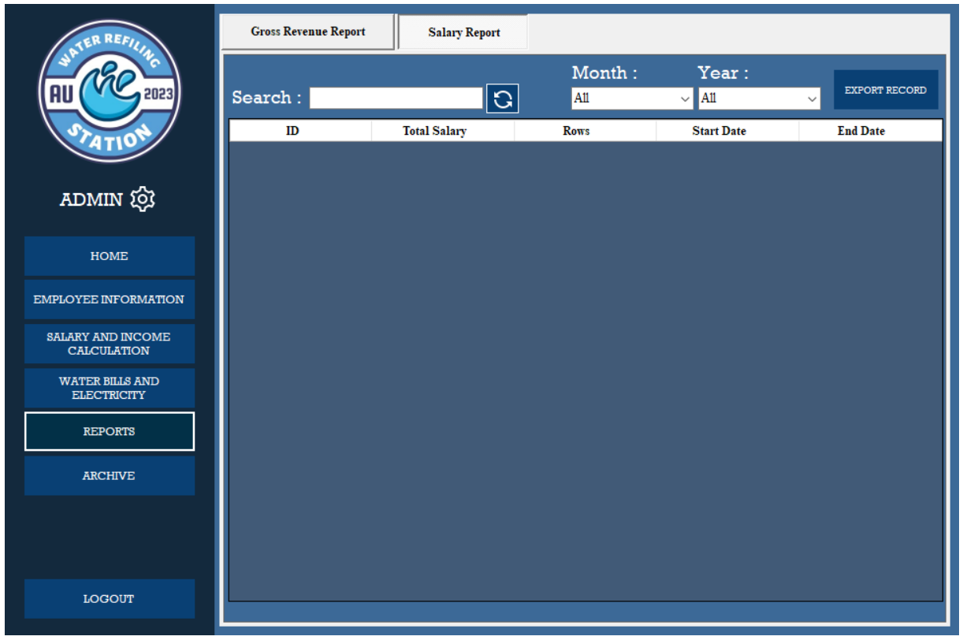

**Image 12. Salary Interface**

1. **Salary Report** – This field show the total salary report

* **Export Record.** A button use to export a soft copy of salary report.
* **Search.** A field use to search in the record table of salary reports
* **Month and Year.** A field use to sort record by month, by year, or by month and year.

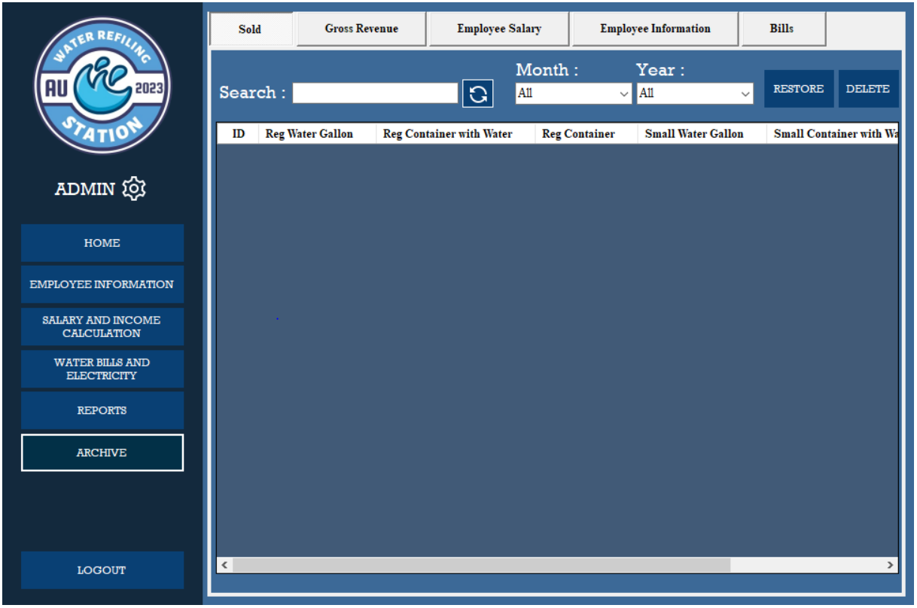

**Image 13. Archive**

1. **Archive.** When you delete some records you can it restore and or permanently.

**CHAPTER 9**

**TECHNICAL DOCUMENTATION**

**TECHNICAL DOCUMENTATION**

This technical documentation serves as a comprehensive guide for the Sales Commission System designed for Au Water Refilling Station. It provides detailed information to help readers understand, configure, and effectively use the system.

This documentation offers detailed explanations of key concepts and components, ensuring a thorough understanding of the system's functionality. It includes the database structure, troubleshooting procedures, and strategies for system testing and maintenance to ensure smooth operation and long-term sustainability.

**Installation Guide**

An installation guide is a list of step-by-step instructions regarding the setup of software, hardware, or systems to ensure proper working. It involves the tools needed, configurations, and procedures a user must undergo during the installation.

**Hardware Requirements**

The hardware requirements ensure the capability of the system to run properly and smoothly in the desktop device with least encountered problems occur.

* **Processor.** Intel Core i3 or higher
* **RAM.** At least 8GB
* **Hard Drive.** 256GB SSD or higher
* **Display.** Minimum resolution ng 1024 x 768 pixels

**Software Requirements**

The software requirements ensure the compatibility of the system to run and operates accordingly.

* **Operating System.** Windows 10/11 (64-bit)
* **Database Management System.** SQL Server Management Studio Management Studio 19
* **Framework.** .NET Framework 4.0

**Step-by-Step Instructions for Installing the Software**

Step-by-step instruction helps the developer team and stakeholder to align the goal and meet the criteria in proper installation. It gives them a precise procedure to make the installation works smoothly.

**Step 1. Install SQL Server Management Studio (SSMS)**

Download the SQL Server Management Studio (SSMS) installer onto the user's server. After the SSMS is downloaded, we will proceed with the installation setup on the user's server or unit.

**Step 2. Transfer the System Installer**

After installing SSMS on the user's server or device, the next step is to transfer all the system files we created, including the .exe file. We will thoroughly verify that all the files are intact to prevent any problems when using the system.

**Step 3. Import the Database to SSMS**

After transferring the system files and the .exe file, and downloading SSMS, the next step is to import the required database for the system. Here’s how to do it:

1. Open SQL Server Management Studio (SSMS).
2. Go to the Databases folder.
3. Right-click on Databases and choose Import Data-tier Application.
4. Follow the prompts to complete the database import into the system.

**Step 4. Run the System**

Once we finish all the necessary steps for the system installation, we will proceed to test it to confirm everything is functioning as expected. This involves checking that the installation was completed correctly, ensuring all features are operational, and verifying that the database is running smoothly.

**Configuration Guide**

This is a simple step-by-step instruction manual that helps user make changes or updates in a system. This guide specifically explains how to update your account password, including logging in, navigating to the settings, entering your current and new passwords, saving the changes, and confirming the update. It also provides tips for troubleshooting errors and using the "Forgot Password" option if needed.

**System User Guide: Changing Password**

This guide will help the user change the account password in the system. Follow these steps carefully.

**Access the System**

1. Open the application on your device.
2. Log in with the user’s existing username and password.

**Navigate to the Password Update Section**

1. After logging in, go to the setting.
2. Update form.
3. Select the current data row.
4. Enter the current password.
5. In the current password make sure to input the existing password.

**Enter New Password**

1. In the new password field, type the new password to use.
2. Make sure the new password that entered must not match the current password.

**Confirm Your New Password**

1. In the confirm password field, re-enter the new password exactly as being typed above.
2. Ensure there are no typos.

**Save Changes**

1. Click the update button.
2. Wait for the system to process the changes.

**Confirmation**

1. If update is successful, user will see a confirmation message like.

*“User Profile Update Successfully.”*

1. If there are errors, follow the instruction provided by system (e.g. *“Current password is incorrect”* or *“The New Password and Confirmation Password do not match.”*

**Log in with Your New Password**

1. Log out the System.
2. Use the new password to log back in and confirm it works.

**Note:** If you forget your current password, use the forgot password option the password will send to your registered email account.

**API Documentation**

The login form serves as an authentication method to verify that a user is authorized to access the system. If a user forgets their password, they can use the Forgot Password option to recover their account.

**API Overview**

This API provides authentication functionality, allowing user to log in securely and recover their accounts if they forget their password.

**API Endpoints**

|  |  |  |
| --- | --- | --- |
| Method | Endpoint | Description |
| POST | /api/auth/login | Authenticates a user using email & password |
| POST | /api/auth/forgot-password | Requests password reset, sends OTP to registered Gmail. |
| POST | /api/auth/verify-otp | Verifies the OTP entered by the user. |
| POST | /api/auth/reset-password | Allows user to set a new password after OTP verification. |

**API Details**

**Login API**

1. Endpoint. POST /api/auth/login
2. Request Body. {“username": "*registered username*", "password": "*registered password*”}
3. Response (Success – 200 OK). {“message": "Login successful", "token": "*the token...*”}
4. Response (Error – 401 Unauthorized). {“error": "Invalid username or password", "Login Failed”}

**Forgot Password API**

1. Endpoint. POST /api/auth/forgot-password
2. Request Body. {“email": "*the registered Gmail account*”}
3. Response (Success - 200 OK). {“message": "An OTP has been sent to your email. Please check your inbox.", "Success”}
4. Response (Error - 404 Not Found). {“error": "The email address you entered is not registered in the user profile.", "Error"}

**OTP Verification API**

1. Endpoint. POST /api/auth/verify-otp
2. Request Body. {“email": "*the registered Gmail account*”, “otp”, “*generated otp”*}
3. Response (Success - 200 OK). (No message, proceed to change password)
4. Response (Error - 404 Not Found). {“error": "The email address you entered is not registered in the user profile.", "Error"}

**Recovery Flow**

* + - 1. The user enters their username and password in the login form.
      2. If the user forgets their password, they can select the Forgot Password option.
      3. The system prompts the user to enter their registered Gmail account.
      4. Once submitted, the system verifies if the email exists in the database.
      5. If the email is valid, the system generates a One-Time Password (OTP) and sends it to the user via Gmail.
      6. The user checks their Gmail inbox for the OTP and enters it into the application.
      7. The system validates the OTP.
* If the OTP is correct, the user proceeds to the Change Password screen.
* If the OTP is incorrect or expired, the system prompts the user to request a new OTP.
  + - 1. The user enters and confirms a new password in the Change Password form.
      2. The user enters and confirms a new password in the Change Password form.
      3. The system updates the user's password in the database.

The user is redirected to the login screen, where they can now access the system using the new password.

**Code Documentation**

This code documentation explains how the piece of code works, it helps developers understand, use, and maintain the code efficiently. It also can be a guide for future researchers to understand the structure and flow of the development and the important components that has been used by the software engineer in developing the system.

**Connection Class**

The connection class is responsible for establishing a secure connection between the application and the SQL Server database. This class ensures efficient data retrieval, insertion, updating, and deletion operations while handling potential database connection issues. In the connection class, the declaration was done each form because of the software engineer limitation of not using the module by the reason of not being much familiarized of its functionality.

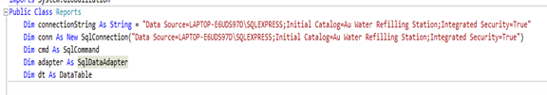

**Image 14. One of the Connection Class: Reports**

**Explanation of Functionality**

1. **Define Connection String**. Stores database connection details, including server name, database, and authentication mode.
2. **Initialize Connection.** Creates a SqlConnection object using the connection string to establish a connection to the database.
3. **Prepare SQL Command.** Declares a SqlCommand object for executing SQL queries (SELECT, INSERT, UPDATE, DELETE).
4. **Initialize Data Adapter.** Declares a SqlDataAdapter to fetch data from the database and fill a DataTable.
5. **Define Data Table**. Declares a DataTable to store retrieved data for display or processing.

**Login Form**

The login form serves as the authentication mechanism for the system. It ensures that only valid user can access the system by verifying the input credentials against the database.

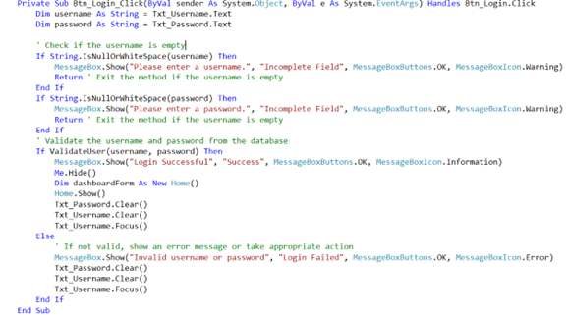

**Image 15. Login Validation**

**Explanation of Functionality**

1. **Retrieve Input.** Captures the username and password from Txt_Username and Txt_Password.
2. **Validate Input.** Checks if the username or password fields are empty and prompts the user if necessary.
3. **Authenticate User.** Calls ValidateUser(username, password) to verify credentials against the database.
4. **Successful Login.** Shows a success message, hides the login form, opens the home form, and clears input fields.
5. **Failed Login.** Shows an error message, clears input fields, and refocuses on Txt_Username.

**Forgot Password**

The Forgot Password functionality allows user to recover their account in case they forget their login credentials. It ensures account security by verifying the user’s registered email and providing a secure way to reset the password. The process involves user verification, generating a reset token, sending a reset link via email, and updating the password in the database. This feature integrates with a third-party email service Gmail to send password recovery instructions to the user’s registered email address.

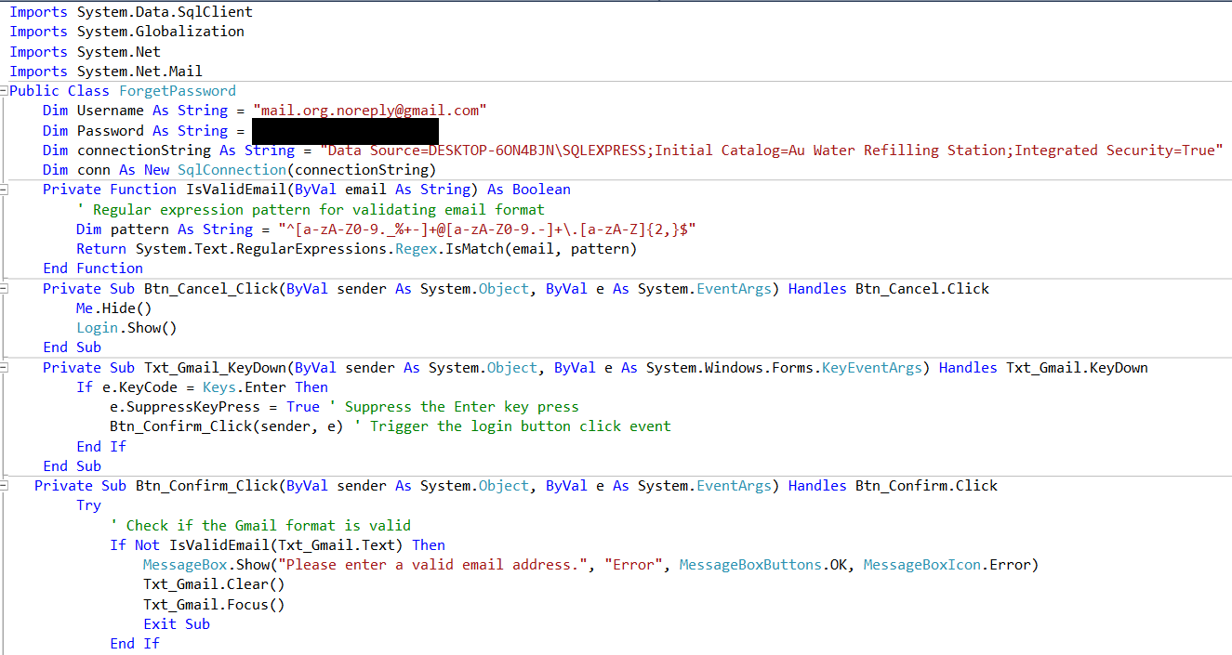

**Image 16-1. Forgot Password and API**

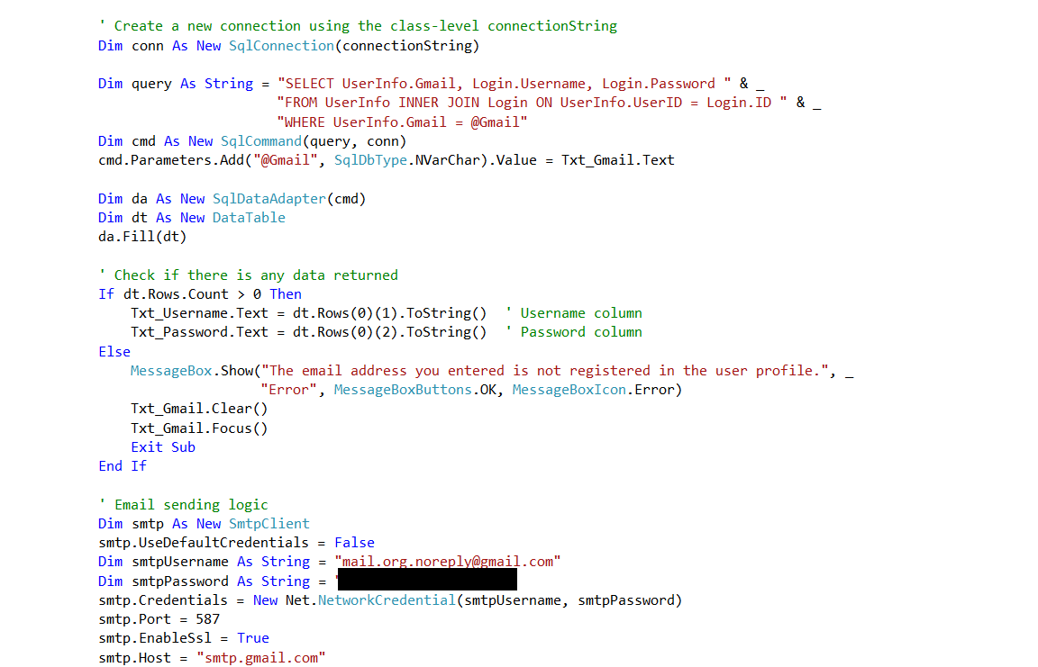

**Image 16-2. Forgot Password and API**

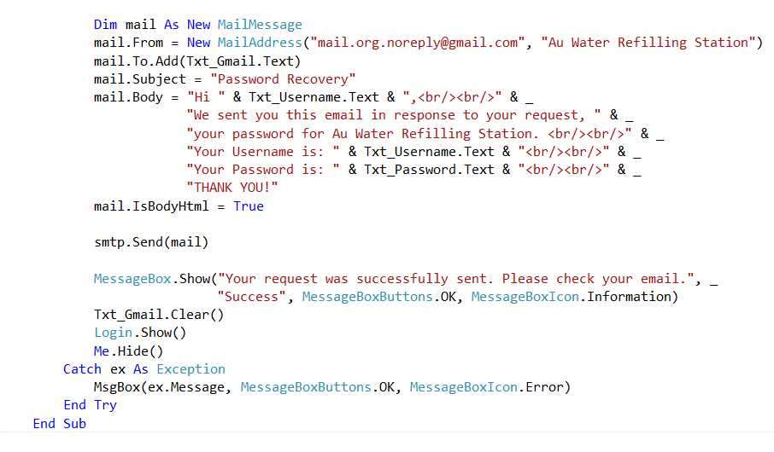

**Image 16-3. Forgot Password and API**

**Explanation of Functionality**

1. **Validate Email Input**. The system checks if the entered email in Txt_Gmail is valid using the IsValidEmail() function.
2. **Handle Invalid Email**. If the email is invalid, an error message is displayed, and the email textbox is cleared.
3. **Connect to Database.** Uses SqlConnection to establish a connection with the database.
4. **Execute SQL Query.** Searches for the username and password in the Login table where the email matches the entered one.
5. **Check Query Result**. If a record is found, the username and password are displayed in the textboxes. If no record is found, an error message is shown, and the email field is reset.
6. **Send Recovery Email**. Uses SMTP Client to send an email containing login details to the user's Gmail account.
7. **Ensure Email Delivery**. The system requires correct email credentials and SMTP server settings to send the email successfully.

**Sold**

The sold functionality allows user to record the daily sales of the business. Every amount that has been input to the fields has multiplier base on the prices of the gallon. This ensures to adapt the functionality of recording of user from manual to computerized way.

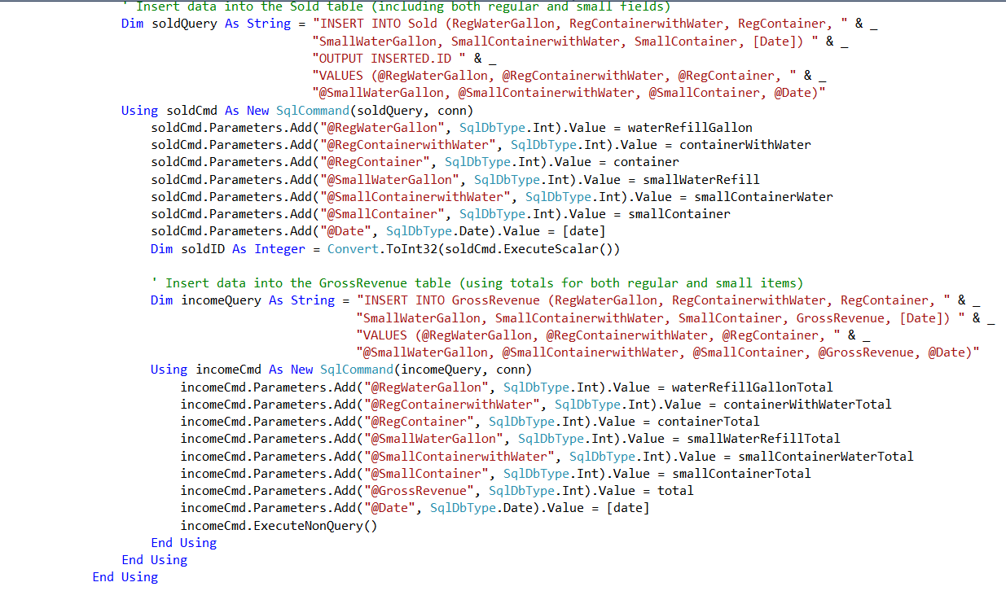

**Image 17. Sold Query**

**Explanation and Functionality**

1. **Input Sales Amount.** The user enters the total sales amount for the specific day.
2. **Retrieve Price per Gallon.** The system fetches the user-defined price per gallon from the database or settings.
3. **Calculate Gross Revenue.** Multiplies the entered sales amount by the price per gallon to determine total revenue.
4. **Store Sales Record.** Saves the sales amount, price per gallon, gross revenue, and date in the database.
5. **Display Results.** Shows the total revenue and stored sales information to the user.
6. **Confirm Submission.** Notifies the user that the sales record has been successfully saved.

**Salary**

The salary functionality records employee salaries based on the number of gallons delivered by a delivery employee. The user selects a specific employee, inputs the number of gallons delivered, and submits the data. The system then calculates the salary based on the set commission per gallon and stores the salary record.

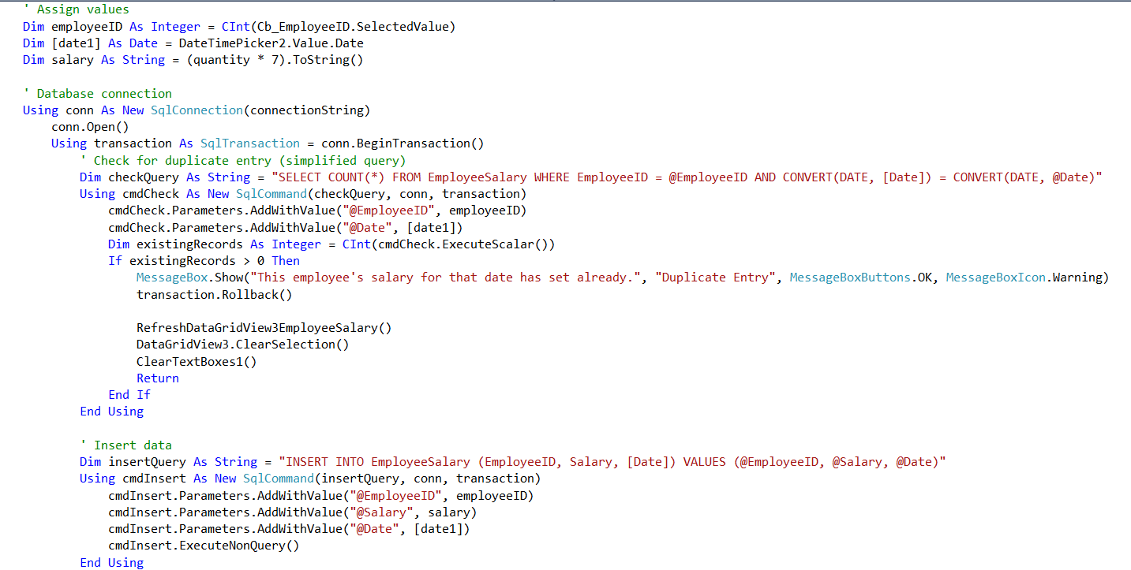

**Image 18. Salary Query**

**Explanation and Functionality**

1. **Select Employee.** The user selects the delivery employee from a list.
2. **Input Delivered Quantity.** The user enters the number of gallons delivered by the employee.
3. **Retrieve Commission Rate.** The system fetches the predefined commission per gallon from the database.
4. **Calculate Salary.** Multiplies the delivered quantity by the commission rate per gallon.
5. **Store Salary Record.** Saves the employee’s name, delivered quantity, commission rate, total salary, and date in the database.
6. **Display Salary Details.** Shows the computed salary and stored record for confirmation.

**Searches**

The SearchByMonthYear function retrieves and displays data from the database based on the selected month and year. It filters entries from the table by checking the StartDate column, ensuring that only records matching the specified month and year are shown.

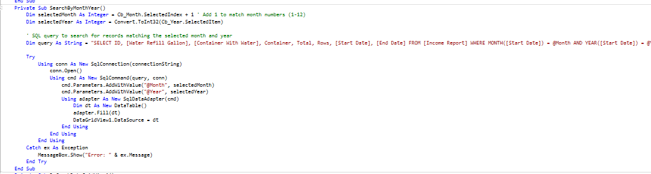

**Image 19. Search Functionality**

**Explanation and Functionality**

1. **Input Month & Year.** The user selects or enters a specific month and year.
2. **Query the Database**. The system executes an SQL query to filter records based on the month and year of the Start Date column.
3. **Retrieve Data**. The matching records are fetched from the database.
4. **Display Results**. The filtered data is shown in the table or UI component.
5. **Handle No Results**. If no records match the criteria, a message is displayed indicating no data found.

**Generate Reports**

The Generate Reports function allows user to select multiple rows from the table, fetch the corresponding data, and determine a date range based on the selected entries. This enables user to generate and view a sales report covering the selected days.

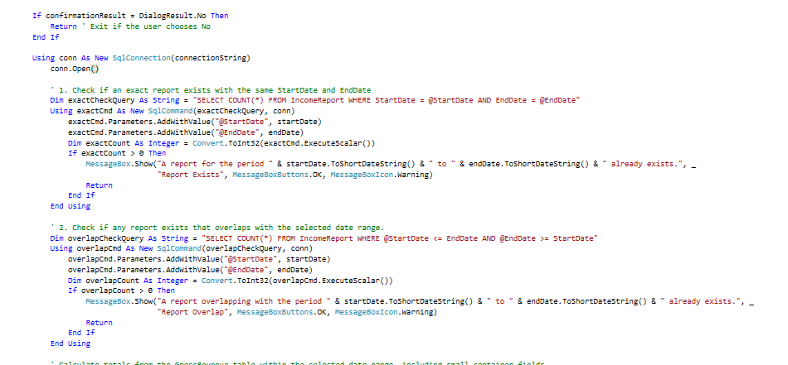

**Image 20. One of the Generate Report: Income Report**

**Explanation and Functionality**

1. **Select Multiple Rows.** The user selects multiple rows from the sales table.
2. **Fetch Selected Data.** The system retrieves the data for the selected rows from the database.
3. **Determine Date Range.** The system reads the Start Date values of the selected entries and determines the range.
4. **Generate Report.** The system compiles the data into a structured report format.
5. **Display Report.** The generated report is displayed to the user, showing sales data for the selected days.

**Export Reports**

The Export Reports function allows user to select one or multiple rows from the table and export the data to a file format of their choice. Once the Export button is clicked, the system prompts the user to choose a location on their device to save the file.

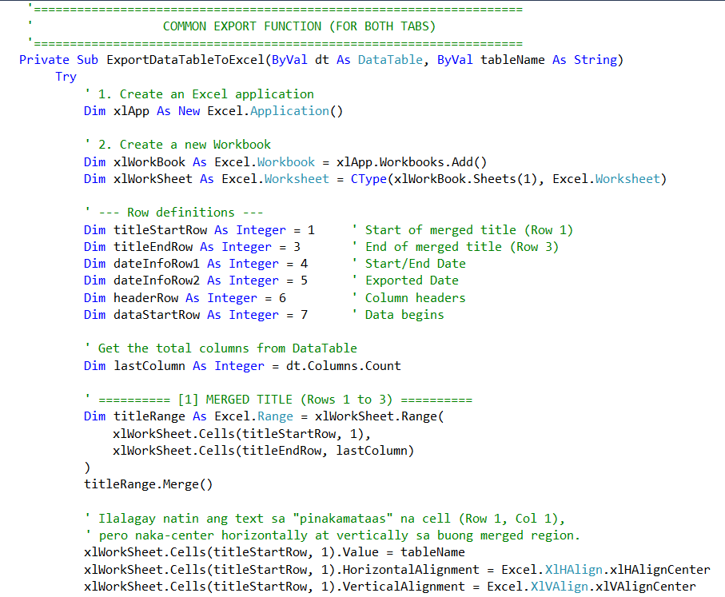

**Image 21-1. Export Report**

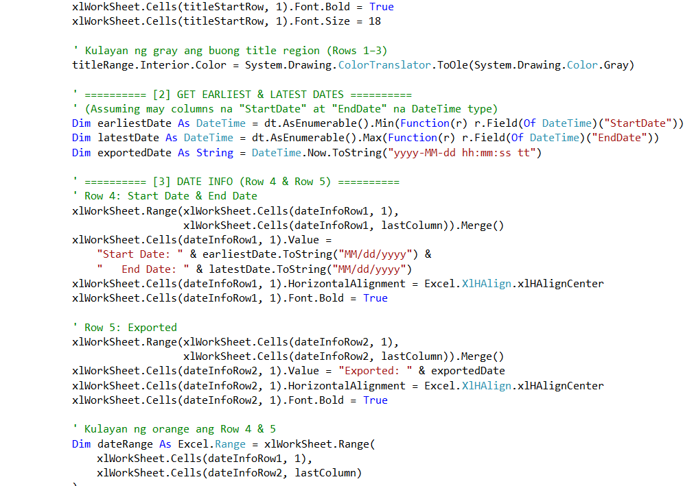

**Image 21-2. Export Report**

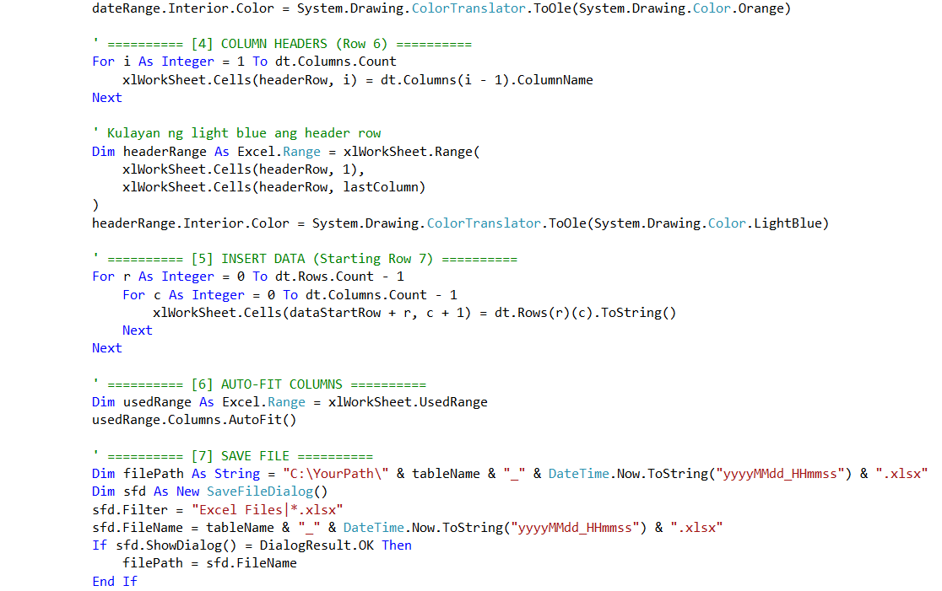

**Image 21-3. Export Report**

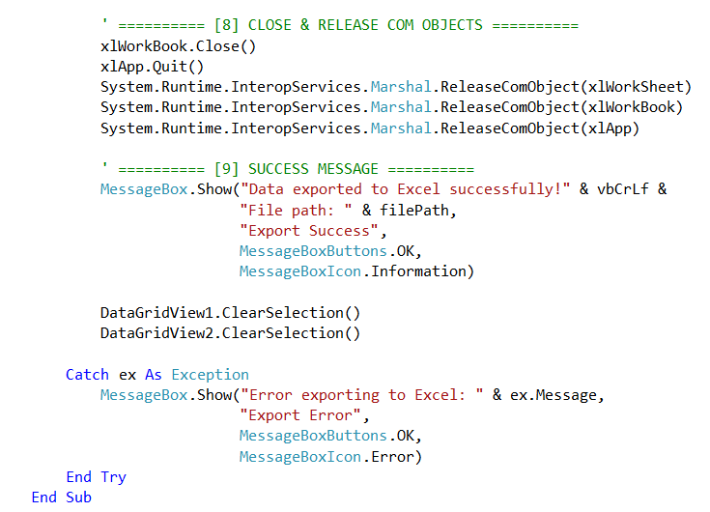

**Image 21-4. Export Report**

**Explanation and Functionality**

1. **Select Rows.** The user selects one or multiple rows from the table.
2. **Click Export Button.** The user clicks the Export button to initiate the process.
3. **Retrieve Selected Data.** The system fetches the data of the selected rows from the database or table.
4. **Choose File Location.** The user is prompted to select the destination folder and file name.
5. **Export Data.** The system converts the data into a specific file format which is Excel, and saves it.
6. **Completion Message.** A confirmation message is displayed once the export is successful.

**Recycle Bin**

The Recycle Bin is a dedicated table that stores deleted data, allowing user to conserve and retrieve information whenever needed. Instead of permanently deleting records, they are moved to the Recycle Bin table, where they can be restored or permanently removed if necessary.

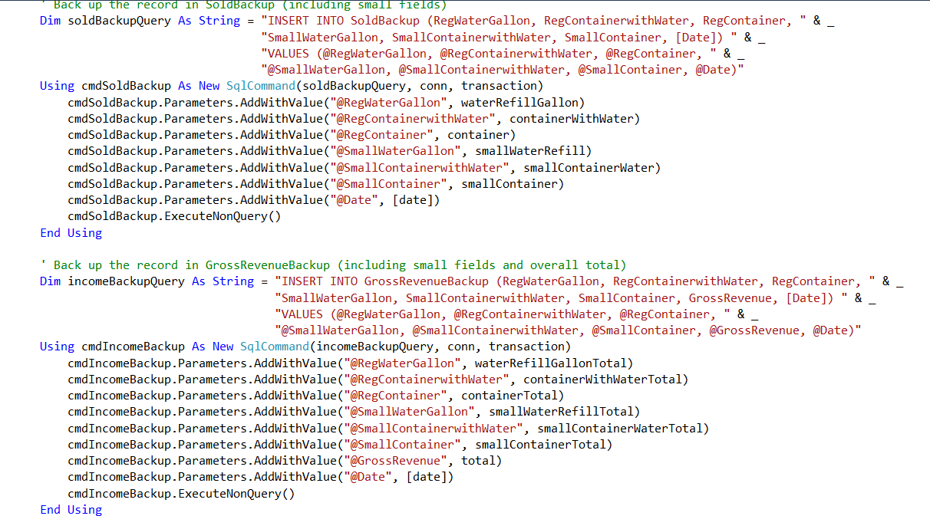

**Image 22-1. Delete and Conserve to Backup Tables**

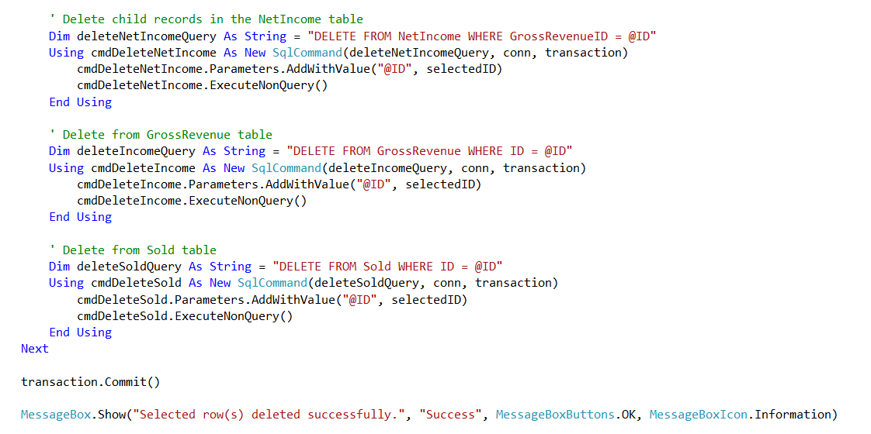

**Image 22-2. Delete and Conserve to Backup Tables**

**Explanation and Functionality**

1. **Delete Record.** When a record is deleted, it is moved to the Recycle Bin table instead of being permanently removed.
2. **Store Deleted Data.** The system saves all relevant information in the Recycle Bin table, including a Deleted Date timestamp.
3. **View Recycle Bin**. The user can access the Recycle Bin to see a list of deleted records.
4. **Restore Data (Optional)**. The user can select a record and click Restore, moving it back to its original table.
5. **Permanent Deletion (Optional)**. The user can choose to permanently delete a record, removing it from the database.

This marks the conclusion of the code documentation. The provided code snippets and blocks illustrate the core functionalities, structure, and implementation details of the system. They serve as a reference for understanding how different components interact, ensuring maintainability, scalability, and ease of future modifications.

**CHAPTER 10**

**TESTING**

**TESTING**

In this section, we demonstrate the examination of the Sales Commission System for AU Water Refilling Station and ensure that every one of its functions are operational. Prior to its actual rollout, a system is subjected to alpha, beta, stress and pen testing which essentially puts the system under real life scenarios to determine its overall usability, performance, and functionality.

**Objectives**

These are the objectives in conducting a system testing, it is to ensure to check every functionality in the system without overlooking things.

1. Ensure all features and functionalities work as intended based on the system’s requirements.
2. Identify defects, inconsistencies, and errors in the system before deployment.
3. Confirm that the system performs well under different conditions without crashing or producing unexpected results.
4. Ensure that the system meets the needs and expectations of user.
5. Verify that data is processed, stored, and retrieved correctly without corruption or loss.
6. Assess the system’s user interface and overall user experience for ease of use.

**Strategies**

These are the testing strategy of the development team conducted; it was performed thorough the development of the system.

1. Alpha Testing. The development team especially the software engineer and system analyst check the system thorough its development.
2. Beta Testing. Allowing other user to try and test the system and ask for feedback, and suggestions for the development team updates.
3. Stress Testing. Pushing the system to its limit, it is a type of trying to work the inappropriate way in a function, form and buttons to see if there are overlooked things that needs to fix.
4. Penetration Testing. This is regarding the security, it is trying to guess and keep on trying to login to the system. This test ensures the functionality of security if it really works well.

**Unit Testing**

The development team did not use a computerized tool of testing otherwise, the team conducted a manual testing for unit testing ensuring the individual components and modules are working appropriately before integrating. The first process for this is the correctness of the input and output behavior therefore, the software engineer provides a restriction and data validation for example, checking of the database connection function if it works correctly and validate some fields in form to input a valid data according to the allowed restriction.

**Integration Testing**

The development team conducted an integration testing after the unit testing was polished and finalized, the objective is to ensure that the multiple forms are working together correctly such as the interactions between the database, APIs, and other components. The development team strictly analyzes and review the data flow between components especially in the sales and salary of the employee for having a crucial relationship to provide an efficient data management for the business. Doing this testing without using any tool in computerized way is risky for having a high risk of overlooking some things and data but, the development team spend a lot of time to check and review to accomplish this test.

**System Testing**

The development team tested the whole application for multiple times and used different types of testing to accomplish this kind of test to ensure the system meets the client’s requirements and functionalities. Starting from user workflows to behavior of the user interface and overall functions performance.

**TEST CASES**

These are the detailed steps, conditions, and expected results used to verify if Sales Commission System for AU Water Refilling Station is intended.

|  |  |  |  |  |  |  |
| --- | --- | --- | --- | --- | --- | --- |
| Test Case ID | Test Description | Test Steps | Expected Output | Actual Output | Status | Remarks |
| TC001 | Login with valid credentials | 1. Enter username 2. Enter password 3. Click login | User is redirected to dashboard | User is redirected to dashboard | Pass | N/A |
| TC002 | Login with invalid passwords | 1. Enter username 2. Enter incorrect password 3. Click login | Error message appears | Error message appears | Pass | N/A |
| TC003 | Adding new employee information | 1. Enter full name 2. Enter Contact number 3. Address 4. Choose date 5. Click Submit | A message showing that adding new employee is successful | A message showing that adding new employee is successful | Pass | N/A |
| TC004 | Updating employee information | 1. Retrieve information from table records 2. Choose and enter the update data | message showing that updating employee is successful | message showing that updating employee is successful | Pass | N/A |
| TC005 | Deleting new employee | 1. Retrieve information from table records 2. Click Delete | Confirmation message showing if  the user is sure in deleting the employee information | Confirmation message showing if  the user is sure in deleting the employee information | Pass | N/A |
| TC006 | Adding new sold gallons | 1. Enter regular water gallon 2. Enter Container  with water 3. Enter regular container sold 4. Enter small water gallon 5. Enter small Container  with water 6. Enter small container sold 7. Click Submit | Show message that adding new sales is successful | Show message that adding new sales is successful | Pass | N/A |
| TC007 | Updating sold gallons | 1. Retrieve information from table records 2. Choose and enter the update data 3. Click Update | message showing that updating sold data is successful | message showing that updating sold data is successful | Pass | N/A |
| TC008 | Deleting sold gallons | 1. Retrieve information from table records 2. Click Delete | Confirmation message showing if  the user is sure in deleting the sold information | Confirmation message showing if  the user is sure in deleting the sold information | Pass | N/A |
| TC008 | Generating Sold Reports | 1. Select at least two rows from table records 2. Click generate report | message showing that the user is requesting for report for chosen date in the chosen rows | message showing that the user is requesting for report for chosen date in the chosen rows | Pass | N/A |
| TC009 | Inputting salary for employee | 1. Choose the Fullname of employee 2. Choose date of sales 3. Enter Quantity 4. Click Submit | Show message that recording the sales of an employee is successful | Show message that recording the sales of an employee is successful | Pass | N/A |
| TC010 | Updating salary for employee | 1. Retrieve information from table records 2. Choose and enter the update data | message showing that updating the data is successful | message showing that updating the data is successful | Pass | N/A |
| TC011 | Deleting salary of employee | 1. Retrieve information from table records 2. Click Delete | Confirmation message showing if  the user is sure in deleting the salary of employee | Confirmation message showing if  the user is sure in deleting the salary of employee | Pass | N/A |
| TC012 | Generating Salary  Reports | 1. Select at least two rows from table records 2. Click generate report | message showing that the user is requesting for report for chosen date in the chosen rows | message showing that the user is requesting for report for chosen date in the chosen rows | Pass | N/A |
| TC013 | Recording the monthly expenses | 1. Enter Electricity Bill 2. Enter Water Bill 3. Water filter 4. Date 5. Click Submit | message showing that recording the expenses is successful | message showing that recording the expenses is successful | Pass | N/A |
| TC014 | Updating the monthly expenses | 1. Select row from the record table 2. Choose and enter the updated data 3. Click Update | message showing that updating the record data is successful | message showing that updating the record data is successful | Pass | N/A |
| TC015 | Deleting the monthly expenses | 1. Select row from the record table 2. Click Delete | Confirmation message showing if  the user is sure in deleting the record of expenses | Confirmation message showing if  the user is sure in deleting the record of expenses | Pass | N/A |
| TC016 | Exporting Gross Revenue Report | 1. Select row from the record table 2. Click Export Record | A file manager windows shows and can choose where to save the exported report | A file manager windows shows and can choose where to save the exported report | Pass | N/A |
| TC017 | Exporting  Salary Report | 1. Select row from the record table 2. Click Export Record | A file manager windows shows and can choose where to save the exported report | A file manager windows shows and can choose where to save the exported report | Pass | N/A |
| TC018 | Restore sold record | 1. Select row from the record table 2. Click Restore | A message will show saying that the restoration of record is successful | A message will show saying that the restoration of record is successful | Pass | N/A |
| TC019 | Permanently deleting sold record | 1. Select row from the record table 2. Click Delete | Confirmation message showing if  the user is sure in permanently deleting the record of sales | Confirmation message showing if  the user is sure in permanently deleting the record of sales | Pass | N/A |
| TC020 | Restore gross revenue report record | 1. Select row from the record table 2. Click Restore | A message will show saying that the restoration of record is successful | A message will show saying that the restoration of record is successful | Pass | N/A |
| TC021 | Permanently deleting gross revenue report record | 1. Select row from the record table 2. Click Delete | Confirmation message showing if  the user is sure in permanently deleting the record of gross revenue report | Confirmation message showing if  the user is sure in permanently deleting the record of gross revenue report | Pass | N/A |
| TC022 | Restore employee salary record | 1. Select row from the record table 2. Click Restore | A message will show saying that the restoration of record is successful | A message will show saying that the restoration of record is successful | Pass | N/A |
| TC023 | Permanently deleting employee salary record | 1. Select row from the record table 2. Click Delete | Confirmation message showing if  the user is sure in permanently deleting the record employee salary report | Confirmation message showing if  the user is sure in permanently deleting the record employee salary report | Pass | N/A |
| TC024 | Restore employee information record | 1. Select row from the record table 2. Click Restore | A message will show saying that the restoration of record is successful | A message will show saying that the restoration of record is successful | Pass | N/A |
| TC025 | Permanently deleting employee information record | 1. Select row from the record table 2. Click Delete | Confirmation message showing if  the user is sure in permanently deleting the record employee information | Confirmation message showing if  the user is sure in permanently deleting the record employee information | Pass | N/A |
| TC026 | Restore bills record | 1. Select row from the record table 2. Click Restore | A message will show saying that the restoration of record is successful | A message will show saying that the restoration of record is successful | Pass | N/A |
| TC027 | Permanently deleting bills record | 1. Select row from the record table 2. Click Delete | Confirmation message showing if  the user is sure in permanently deleting the record of the bills | Confirmation message showing if  the user is sure in permanently deleting the record of the bills | Pass | N/A |
| TC028 | Logging out | 1. Click Logout | Confirmation message showing if  the user is sure on logging out | Confirmation message showing if  the user is sure on logging out | Pass | N/A |

**CHAPTER 11**

**DEPLOYMENT**

**DEPLOYMENT**

This document shares the steps and setup needed to successfully launch the Sales Commission System for AU Water Refilling System. It serves as a helpful resource for everyone involved, particularly development team and the stakeholder, to make the deployment process successful.

**Deployment Environment**

The deployment environment section provides a detailed breakdown of where and how the software will be installed, configured, and maintained. This section is crucial for developers, and stakeholder to understand the infrastructure, software requirements, security measures, and deployment process needed to ensure the system runs efficiently.

**Hardware Requirements**

The hardware requirements ensure the capability of the system to run properly and smoothly in the desktop device with least encountered problems occur.

1. **Type:** On-premises
2. **Processor**. Intel Core i3 or higher
3. **RAM.** At least 8GB
4. **Hard Drive.** 256GB SSD or higher
5. **Display.** Minimum resolution 1024 x 768 pixels

**Software Requirements**

The software requirements ensure the compatibility of the system to run and operates accordingly.

1. **Operating System.** 10/11 (64-bit)
2. **Database Management System.** SQL Server Management Studio 19
3. **Framework.** .NET Framework 4.0

**Deployment Steps**

This is the step-by-step guide on how to deploy the system in AU Water Refilling Station business workplace.

**Pre-Deployment Steps**

1. Organize the hardcopies of data of the business regarding the sales and employee salary, if necessary, it is for in case the client wants to insert the data from the book to computerized.
2. Check the setup of the hardware devices such as the desktop and its peripherals in the workplace of the client if adjustments needed act accordingly.
3. Install the software applications to use to support the overall functionality of the system such as the system application itself and the SQL Server Management Studio 19 (SSMS19).

**Deployment Execution**

1. Import the database bacpac file in the SSMS19 for the database of the system.
2. Run the system and check for all over functionality for assurance that everything is working appropriately.

**Post-Deployment Steps**

1. Introduce the system and discuss the proper workflow and functionalities of the system, as well as provide the user manual for guidance.
2. Monitor the running time of the system while being used by the client and take a note of primary issues faced.
3. Inform the client of what are most common errors or issues possibly encounter and the way how to resolve those issues.
4. Let the client use the system for a week, and discuss the importance of the feedback, list of issues encountered while the system is being used or any attempt on the system that is having a problem. Write any suggestion and additional features that needs to be included to the system.
5. Development team, consults the result of the client for using the system after a week and collect the list written if there’s any.

**CHAPTER 12**

**MAINTENANCE**

**MAINTENANCE**

This Maintenance Documentation provides guidelines for ensuring the continuous functionality, security, and efficiency of the AU Water Refilling Station’s Sales Commission System. Proper maintenance is essential to prevent system errors, data loss, and security vulnerabilities that could affect daily operations.

**Routine Maintenance Task**

The development team outlines a comprehensive plan and strategy to ensure the system remains stable, secure, and efficient after deployment. This includes regular updates, performance monitoring, security enhancements, and troubleshooting procedures to address any issues that may arise.

1. The development team plans to perform a blue-green testing in deployment that is convenient for maintenance. In regular checking of the system, after the deployment the development team will get the primary issues, bugs, and client suggestion in the very first to second day of the deployment.
2. Let the client use the system for a week with proper information that any issues, bugs and suggestions should be written for future updates.
3. After a week, the development team consults the client if the system works as, it intended and collect the list if there is any.
4. If there are some things need to fix the system will still work and the software engineer will develop the latest version of the application to resolve any issues faced by the client, as well as the suggestions if there is any.
5. Probably the most common issues to occur was the light errors that will affect the fundamental of processes of business productivity.

**Possible Maintenance**

1. **Corrective Maintenance**. The development team, expected this type of maintenance in the first few weeks of the deployment as the client will see some functions and light common problems that probably overlooked by the development team.
2. **Adaptive Maintenance**. The development team prepared themselves for possible additional features whenever the client suggests things to add.
3. **Perfective Maintenance.** This type of maintenance is more likely is not the focus of the development team as they focus more on adaptative software by the client’s need. The development always has room for improvement.
4. **Preventive Maintenance**. This type of maintenance comes along with the corrective maintenance, any type of possible issues to appear in the future will be resolved immediately as long as the development team got sight on it early.

**Backup and Recovery Plan**

This state the backup and recovery plan of the development team for the system, here describes the backup strategy and provide recovery steps in case of data loss or system failure.

**Backup Procedure**

The development team will discuss to the client the importance of the data retrieval to avoid data loss. It includes the possible issues to occur and its answer to resolve.

1. Commonly, to save the data the system has a generate report functionality of specific range of date inserted. It is to conserve the data depends on the client’s need.
2. After the generate report, in reports page that’s the storage of all of the generated reports of data. It also allows the client to select from each row to export the data to the device. It ensures the client to have a softcopy of the data in case of facing system malfunction or data corruption.
3. Here comes the discussion of how to save the data properly, informing the client an export should not be the last step of saving the data because it has risk of data corruption under the device itself when malfunctioned and it will need time to recover.
4. Printing a hardcopy and saving in a safe document folder or workplace would work, therefore it will be one of the suggestions of the development team for data safety.
5. Lastly, the common way to save the file is to save it into the cloud storage or over the network which gives the client the convenient way of accessibility and ensure the data was saved and abled to retrieve under the network connection.

**Upgrading Procedures**

Upgrading procedures are development team plan when the updates, or addition of functions occur it comes with the suggestion of the stakeholder once the system is deployed. To ensure that the team is prepared for scenario like that, the team outline the steps.

1. List down any notices by the stakeholder for the development to conduct an analyzation of the listed notes.
2. Differentiate the prioritization of the listed things, suggestions or bugs fixes.
3. Let the stakeholder to use the system while the development is in progress, and update the stakeholder of what’s the steps been taken for transparency.
4. In this step we’ll use the Green-Blue Deployment which is the replacement of versions of the application when update comes.
5. Repeat the process of testing, deployment and maintenance procedures.

**Recovery Steps**

These are the steps to restore a backup in case of system failure or any data corruption occur in the system.

1. Go to the “Reports” page if still accessible and select the rows from the table that are needed to be save.
2. Once rows are selected, click the “Export” to export the data to an Excel format and save it into document file accordingly to where the businesses files are saved to avoid misplacement of the file.

If the system is not totally accessible and impossible to export the data from it, the secondary way would work.

1. Open the SQL Server Management Studio 19 (SSMS19), search it into the search bar in the task bar if cannot find it in the desktop.
2. Click “Connect” after the SQL Server dialog pop-up.
3. Once connected, click the “Databases”, select the “AU Water Refilling Station” that is the database name of the system.
4. Once the database is selected, right click on it. Point the cursor to “Task” to appear the other selection of choices.
5. In appeared sidebar from task, select the “Export Data-tier Application…”
6. Once selected, click “Next”.
7. It should show the Save to local disk and there is “Browse” button for browsing own desktop folders and locate where the file should be saved.
8. Remember or list down the file path of where the bacpac file is save for easy navigation of the software engineer to locate.

Once the recovery steps are done, kindly contact the support team for further assistance. Provide the following information when reaching out.

**Support Email:** mail.org.noreply@gmail.com

**Note:** When sending us a concern kindly include your contact information as well so, we the development team can contact you directly as soon as we read your email to our support services mail.

**Troubleshooting Guidance**

This is a troubleshooting guide; it is intended to help the user or our stakeholder to identify and resolve possibly common issues encountered while using the Sales Commission System for Au Water Refilling Station.

Therefore, we listed common issues and answer for the user to follow. The steps are outlined below to quickly address the mentioned challenges.

**General Troubleshooting Steps**

Before diving into the specific issues, kindly try these general steps.

1. Restart the software application by clicking the close or exit.
2. If there has problem in closing the application and trying to navigate the Task Manager, you can open the Task Manager by pressing the ALT + CTRL + Del shortcut keys in your keyboard and click the “Task Manager”. When the Task Manager appears, find the running software application in processes and background processes. Select the running application, press right click of your mouse then click “End Task”.
3. If the same problem occurs, let’s deep dive in common issues and solutions.

**Common Issues and Solution**

**AU Water Software Application fails to Load**

If the system doesn’t open when tried opening it there are possible causes.

1. It was already open or running.
2. The computer system requires it to run as an administrator.
3. Incompatible software version.

**Solution**

1. Check the icon in the taskbar if the system is already running.
2. Click right click on the application and select run as an administrator to open.
3. If the issue is incompatible with the software version, contact technical support.

**Unable to Login**

User cannot log in after trying multiple times using her credential.

1. Incorrect username or password.
2. Forgot Password using Gmail is not working.

**Solution**

1. Obtaining the credential using a forgotten password.
2. Double check the email, must be the saved email on the database of an application.

**Problem on Data Input**

User encounter problem when inputting data.

1. The field requirement doesn’t meet.
2. All necessary fields must not leave on blank.

**Solution**

1. Check the error messages to see what kind of error has occur.
2. Make sure to fill all the fields needed and not leave blank, user must put “0” if the data in sales should be none.

**Contact Support**

If the problem persists or is not listed in this guide, please contact our support team for further assistance. Provide the following information when reaching out.

**Support Email:** mail.org.noreply@gmail.com

**Note:** When sending us a concern kindly include your contact information as well so, we the development team can contact you directly as soon as we read your email to our support services mail.

**CHAPTER 13**

**CONCLUSION**

**CONCLUSION**

The conclusion serves as the final section of the documentation, summarizing the overall development, functionalities, and significance of the Sales Commission System for AU Water Refilling Station. It reinforces the system’s purpose, highlights the key features implemented, and reflects on how it meets the business requirements. It acknowledges any challenges faced during development and suggests potential improvements for future enhancements. The conclusion ultimately emphasizes the system’s role in simplify the Sales Commission, ensuring efficiency, accuracy, and ease of use for the client.

**Achievements**

The Sales Commission System for AU Water Refilling Station was successfully developed to enhance the efficiency of managing sales, employee salaries, and financial records. The system provides secure user authentication, computerized sales computation, employee salary calculation, expense recording, and report generation, ensuring a streamlined approach to business operations.

By implementing computerized calculations, the system significantly reduces manual errors and improves data accuracy, making financial tracking more reliable. The integration of a recycle bin for deleted records further ensures data security and recovery when needed. The ability to export reports to Excel enables better record-keeping and decision-making for the business owner.

Throughout the development, the system was designed to be user-friendly and tailored to the client's specific needs, eliminating unnecessary complexities such as inventory tracking while focusing solely on Sales Commission System.

In conclusion, this system serves as a valuable tool in improving operational efficiency, reducing manual workload, and providing accurate business insights. It successfully addresses the challenges of manual record-keeping and salary computation, ultimately benefiting the overall monitoring for growth of AU Water Refilling Station.

**Lesson Learned**

Throughout the development of the Sales Commission System for AU Water Refilling Station, the development team encountered various challenges that required effective communication, collaboration, time management, and problem-solving skills. One of the most important lessons learned by the team is that a clear understanding of objectives and a well-structured workflow are essential in ensuring the successful completion of a project.

Time management proved to be one of the biggest challenges during development. Balancing software development, documentation, and compliance with requirements required discipline and teamwork. Development team realized that starting tasks early and maintaining a consistent pace prevented unnecessary delays and ensured a smooth development process. By prioritizing tasks and initiating them as soon as they were assigned, we were able to avoid workload buildup and maintain steady progress.

Moreover, teamwork and collaboration played a crucial role in development’s success. By working together, sharing ideas, and leveraging each team member’s strengths, the team were able to solve problems efficiently and enhance the overall functionality of the system. Respecting each other's opinions and actively listening to ideas contributed to a smoother workflow and a more productive team dynamic. Open communication helped us avoid misunderstandings, leading to better decision-making and faster progress.

Another key takeaway from this experience is the importance of adaptability and continuous learning. As we encountered technical difficulties and unexpected issues, we had to explore different solutions, improve our skills, and make necessary adjustments to meet the system requirements.

In summary, the development of this system has reinforced the significance of effective teamwork, time management, prioritization, respect, and adaptability in any project. These lessons will serve as valuable foundations for future software development endeavors.

**Future Directions**

While the current version of the Sales Commission System for AU Water Refilling Station successfully meets its core business requirements, there are several potential enhancements that could further improve its functionality and efficiency.

One significant improvement is the integration of graphical sales analysis, which would provide a visual representation of sales trends, revenue patterns, and employee performance over time. This would help in making informed business decisions based on real-time data.

Another enhancement is the addition of multiple user roles to allow for a more structured access control system. This would enable the system to support different levels of access and permissions, ensuring better security and role-specific functionalities for employees and management.

In the future, a mobile version of the system could be developed, allowing users to manage sales, employee records, and reports through their smartphones or tablets. This would provide more flexibility and convenience, especially for business owners who need to monitor operations remotely.

Lastly, transitioning the system to an online platform could further improve accessibility and real-time data management. By moving to a cloud-based solution, users could access the system from anywhere with an internet connection, enhancing overall efficiency and business operations.

These enhancements would significantly elevate the system's usability, making it more scalable, accessible, and adaptable to the evolving needs of the business.

**APPENDICES**

**APPENDIX A – GANTT CHART**

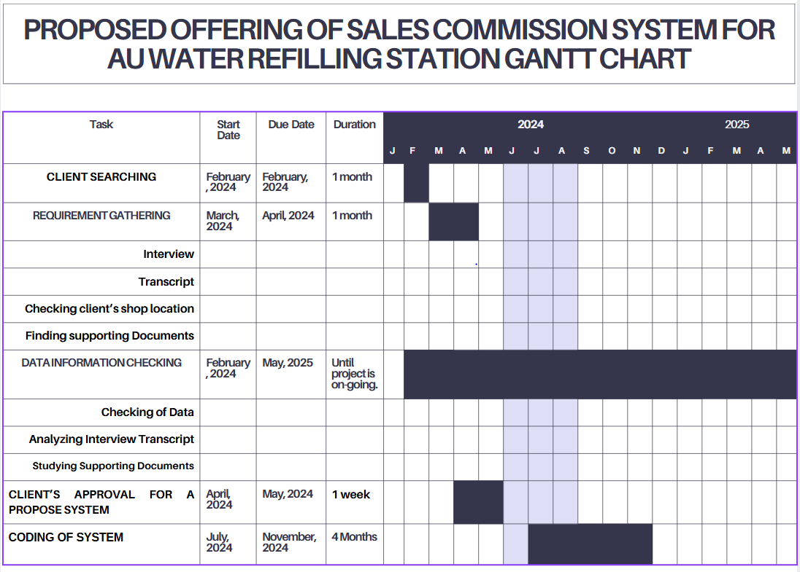

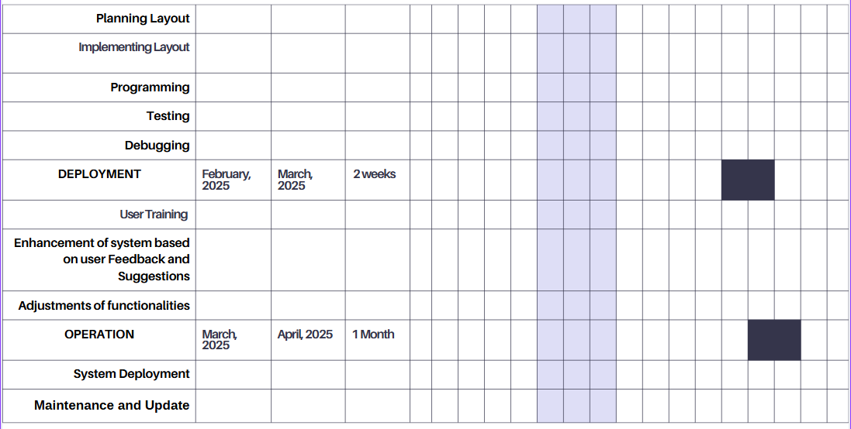

**Figure 4. Sales Commission System Gantt Chart**

**APPENDIX B – INTERVIEW QUESTIONNAIRE**

|  |  |
| --- | --- |
|  | **Questions** |
| 1. | Do you agree to be our client in creating a tools that related to technology? Like a software application that can help to make the ordering process more organize and to make the inventory more accurate.  Tagalog: Pumapayag po ba kayo na maging kapartner kami sa paglikha ng ninanais ninyong kagamitan if ever na ito man ay gamitan ng about sa technology? Such as software applications na makakatulong para maging mas maayos at mabilis ang inyong gawain sa pagoorder nila at pagrerecord nyo. |
| 2. | What are your business hours?  Tagalog: Anong oras po nagbubukas at nagsasara ang inyong shop? |
| 3. | Do you agree that someone will borrow a gallon? If yes, how long do you agree?  Pumapayag po ba kayo na may manghiram ng gallon? Kung oo, gaano katagal po kayo pumapayag? |
| 4. | How many orders per day can you accommodate?  Tagalog: Gaano karami po ang order na kaya nyong tanggapin sa loob ng isang araw? |
| 5. | In recording a stock like the seal, what process do you take?  Tagalog: Sa record ng inyong mga stock kagaya ng sealing, paano nyo ito nirerecord? |
| 6. | How do you record the sale every day?  Tagalog: Sa proseso ng pagrerecord ng nabenta sa isang araw, paano nyo po ito ginagawa? |
| 7. | How do you calculate the salary of your worker?  Tagalog: Paano po ninyo kinokompyut ang sahod ng inyo trabahador? |
| 8. | Are you familiar with using a computer or laptop?  Tagalog: Kayo po ba ay pamilyar sa paggamit ng kompyuter o laptop? |
| 9. | In your current shop, how do you entertain the customer that are willing to order? Do you use an advance technology or still manual proccesing in accomodating them?  Tagalog: in your current shop, paano ninyo hinahandle ang page-entertain sa mga nais mag order? Gumagamit ba kayo ng advance technology or still manual processing sa paga-accomodate para sa kanila? |
| 10. | • Do you experience challenges or problems when taking orders? If yes, can you enumerate it?  Tagalog: Nakakaranas ka ba ng challenges o problema sa pagkuha o pagtanggap ng reservation? Kung oo, maaari nyo po bang sabihin kung ano mga ito? |
| 11. | What are your worst experiences as the owner of the shop?  Tagalog: Ano ang iyong pinaka hindi kaaya aya karanasan bilang may-ari ng shop? |
| 12. | How do you handle it when someone cancels their orders at the last minute? What actions do you take in this kind of situation?  Tagalog: Paano po ninyo hinahandle kapag may nagcancel ng order at last minute? Sa paanong paraan nyo po ito inaaksyunan? |
| 13. | Have you ever dealt with rush order and multiple orders the same time?  Tagalog: May nangyare na po bang nagkaroon ng rush order at sumabay pa sa madaming pending na order? |
| 14. | Is there any chance that the record of sales in a day is not accurate?  Tagalog:May pagkakataon na po bang hindi nagtugma ang inyong mga benta sa loob ng isang araw o isang buwan? |
| 15. | As the Owner po the shop, what are your suggestions or request to us in makih the system that can help to lessen your workload?  Tagalog: Bilang may-ari ng shop, ano po ang inyong masasuggest o marerequest sa amin na patungkol sa pagbuo ng isang system na makakatulong at makakapagpaagaan ng trabaho sa inyong shop? |

**Follow up**

|  |  |
| --- | --- |
| 1. | Kailan nagstart yung business mo? |
| 2. | Magkano yung naging budget nyo sa pagtatayo ng business? |
| 3. | San kayo kumukuha ng supply ng gallon? |
| 4. | Goal nyo bakit nag tayo kayo ng water station? |

**APPENDIX C – CURRICULUM VITAE**

